

Job AnalyticsUser Manual



Daniel O’Sullivan  
Student Number: 14307881

Supervisor: Suzanne Little

Table of Contents

* Introduction………………………………………………………………………………………………2
* Installation Instructions…………………………………………………………………………….2
  + Hardware Requirements………………………………………………………………..2
  + Software Requirements………………………………………………………………….2
  + Instructions for setting up project on localhost……………………………3
* Overview…………………………………………………………………………………………………..4
  + Technical description……………………………………………………………………..4
    - What is CV Parsing?.......................................................................4
    - What is Machine Learning?..........................................................5
* Usage Instructions…………………………………………………………………………………...7
  + Employer………………………………………………………………………………………...7
    - Creating a user……………………………………………………………………..7
    - Logging in……………………………………………………………………………..9
    - Posting a job………………………………………………………………………...11
    - Viewing applicants………………………………………………………………15
    - Updating a job……………………………………………………………………..19
    - Deleting a job……………………………………………………………………...21
    - Deleting an applicant…………………………………………………………22
    - Deleting your user account……………………………………………….24
  + Applicant……………………………………………………………………………………….26
    - Searching for a job…………………………………………………………….26
    - Applying for job………………………………………………………………….27

Introduction

Job Analytics is a web application for employers and applicants to post and find jobs. Employers can post jobs on the app and applicants can apply for open positions. When an employer gets a CV from an applicant, the application will examine an applicant’s CV and return how qualified that person is for the specific role and will also predict how well that person will perform in the role. The idea behind this is to make recruiting for an open vacancy easier by letting the application do all the work for them. All the application needs is a CV. The application will provide the employer with some statistics about their pool of applicants that have applied for their job postings. Job Analytics is built using the Django web framework and uses a Random Forest classifier to predict applicant work ethic.

This application was built to make the hiring process easier. Reading through countless curriculum vitaes can be a time consuming and exhausting task. Job Analytics does the hard work for you. It will read through all the CVs, match them to the posted and return statistics about your applicants. All you have to do is decide which applicant to interview. In this manual, I will talk about how the application was made and how to carry certain tasks step by step.

Installation Instructions

Job Analytics is a web application. To use this app all you need is an internet connection and a web browser.

Hardware Requirements

You can access the web application from any internet browsing device e.g. computer, laptop, phone, tablet etc. However, it is recommended to use this application on a computer/laptop.

Software Requirements

The only software needed to run this application is a web browser e.g. Chrome, Firefox, Safari etc. For setting up the application on your machine’s localhost, you must have **python** and **pip** installed on your machine. You then must find the text file labelled **“requirements”** in the directory **2018-ca400-osulld42/src/jobanalytics** (this after you have downloaded the repository of course).You then must open your command prompt or terminal (depending on your operating system), navigate to the directory where the requirements text file is located and run the command **pip install -r requirements.txt.** You can optionally set up a python virtual environment before running this command. This will install all the software requirements needed to run this application. This may take a few minutes to install everything. You must also have PostgreSQL downloaded and installed on your machine with a database set up. There are plenty tutorial online of how to do this depending on your operating system.

Instructions for setting up project on localhost

To set up Job Analytics on your machine’s localhost, you must follow the following steps (**NOTE: please read software requirements section first before performing these steps)**:

1. Download the Gitlab repository from the following link: <https://gitlab.computing.dcu.ie/osulld42/2018-ca400-osulld42.git>
2. Once everything has downloaded, open your command prompt/terminal (depending on your operating system)
3. Navigate to the directory **<path_to_repo_on_your_machine>/2018-ca400-osulld42/src/jobanalytics/backend/backend** and open the python file labelled “settings”, in your preferred text editor.
4. Scroll down in the settings file until you see a python dictionary labelled “DATABASES”. This is where you put the information of your localhost database (which should have been set up beforehand). Put in your database information.
5. Go back to your command prompt and navigate to the directory **<path_to_repo_on_your_machine>/2018-ca400-osulld42/src/jobanalytics/backend .** This should contain a python file called **“manage”(manage.py).**
6. Run the following commands in order:
   1. python manage.py makemigrations
   2. python mange.py migrate
   3. python manage.py collectstatic
   4. python manage.py runserver
7. And that’s it! The application should now be running on your localhost (localhost:8000 or 127.0.0.1:800).

Overview

Technical Description

Job Analytics uses text parsing and machine learning methods to:

* Read an applicant’s CV and summarise it
* Predict how well an employee will work

You might be wondering what text parsing and machine learning are. I’ll explain each of these in a simple manner.

What is CV parsing?

Text parsing is the act of analysing natural language (e.g. English). Parsing can be used to analyse stuff like meaning of words, spelling, grammar and more. It breaks down text into components in order to learn about it. CV parsing is text parsing for curriculum vitaes. Job Analytics uses CV parsing to read through an applicant’s CV and returns a match score, based on how much they match the job. It also summarises the CV so you don’t have to read through every single one.

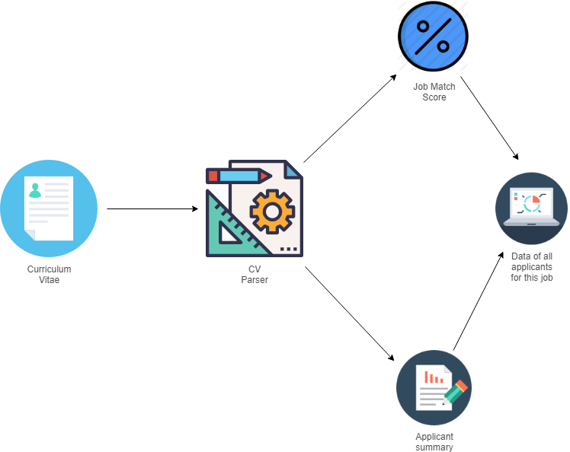

What is Machine Learning?

Machine learning is field of computer science that allows for computers to learn from data. The more data you give it, the more it will learn. Instead of telling the computer or program what to do, it will learn by itself. Machine learning can be used to carry out tasks such as prediction, pattern recognition, text recognition and more. We use a machine learning algorithm to predict an applicant’s work ethic i.e. how much of a hard worker the applicant is. Our algorithm uses a dataset to learn how to do this. A dataset, in simple terms, in a massive spreadsheet filled with data. It uses the attributes (columns) and inputs (rows) to learn what makes a hard working employee and attempts to predict this. To do this prediction, we need to obtain information from our applicants. When an applicant applies for a job, they are asked to fill out a quick form which will supply the information we need to make our prediction. The information we need to predict employee work ethic is as follows:

* **Satisfaction level:** How happy an employee is in their role on a scale of 0 - 1
* **Average Monthly Hours:** Average monthly hours at the workplace
* **Time spent at the company:** How long an employee has been with the company in years
* **Work Accident:** Whether the employee has had a work accident or not (1 or 0)
* **Promotion in the last 5 years:** Whether they’ve had a promotion in the last 5 years (1 or 0)
* **Number of Projects:** The number of projects worked on while at work
* **Salary:** What kind of salary the employee is earning (low, medium or high)

Once we obtain this information, we can make our prediction. Employees can be predicted into 1 of 3 classes.

|  |  |
| --- | --- |
| **Class Label** | **Evaluation Range** |
| Excellent Worker | 100 - 70 |
| Satisfactory Worker | 70 - 40 |
| Poor Worker | 40 - 0 |

These classes are designed to give you a better idea of what kind of employee you are potentially hiring. In my experience in a working environment, i’ve learnt that you only really recognise two kinds of employees:

* The excellent workers who stand out and go beyond their work duties specified in their role.
* The poor workers who stand out because of one or multiple negative attributes they have (e.g. lazy, bad punctuality etc).

Then there are also the workers who I have labelled, for the lack of a better term, satisfactory. These are the workers who are just below excellent but not enough to really stand out and catch your eye. They meet an acceptable standard of work ethic.

Usage Instructions

Employer

Creating a User

To create user on Job Analytics, first navigate to the url of the web application in your preferred web browser. Once the application loads you should be presented with this page:

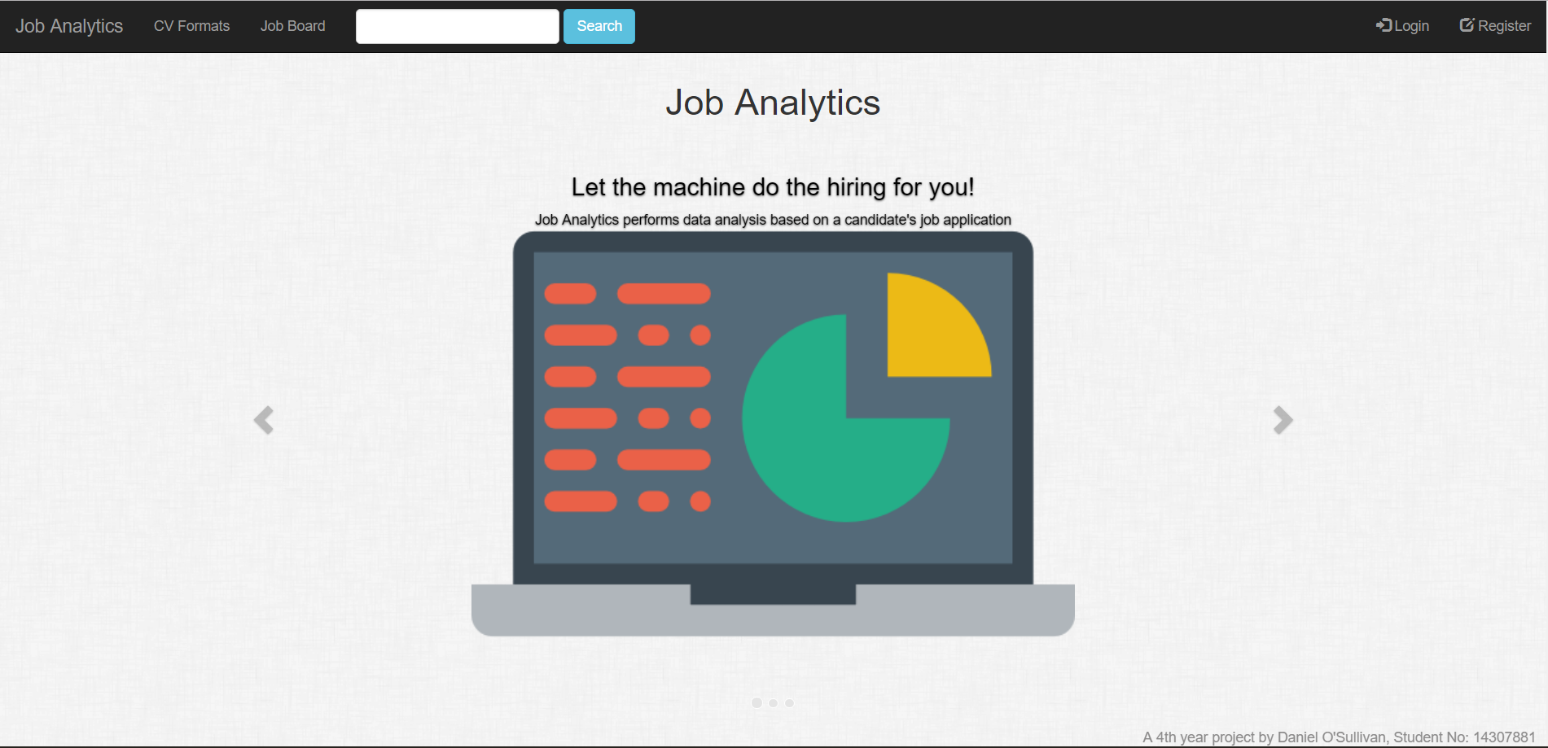

To register a user, click the button labelled “Register” displayed in the top right hand corner of the screen in the black navbar.

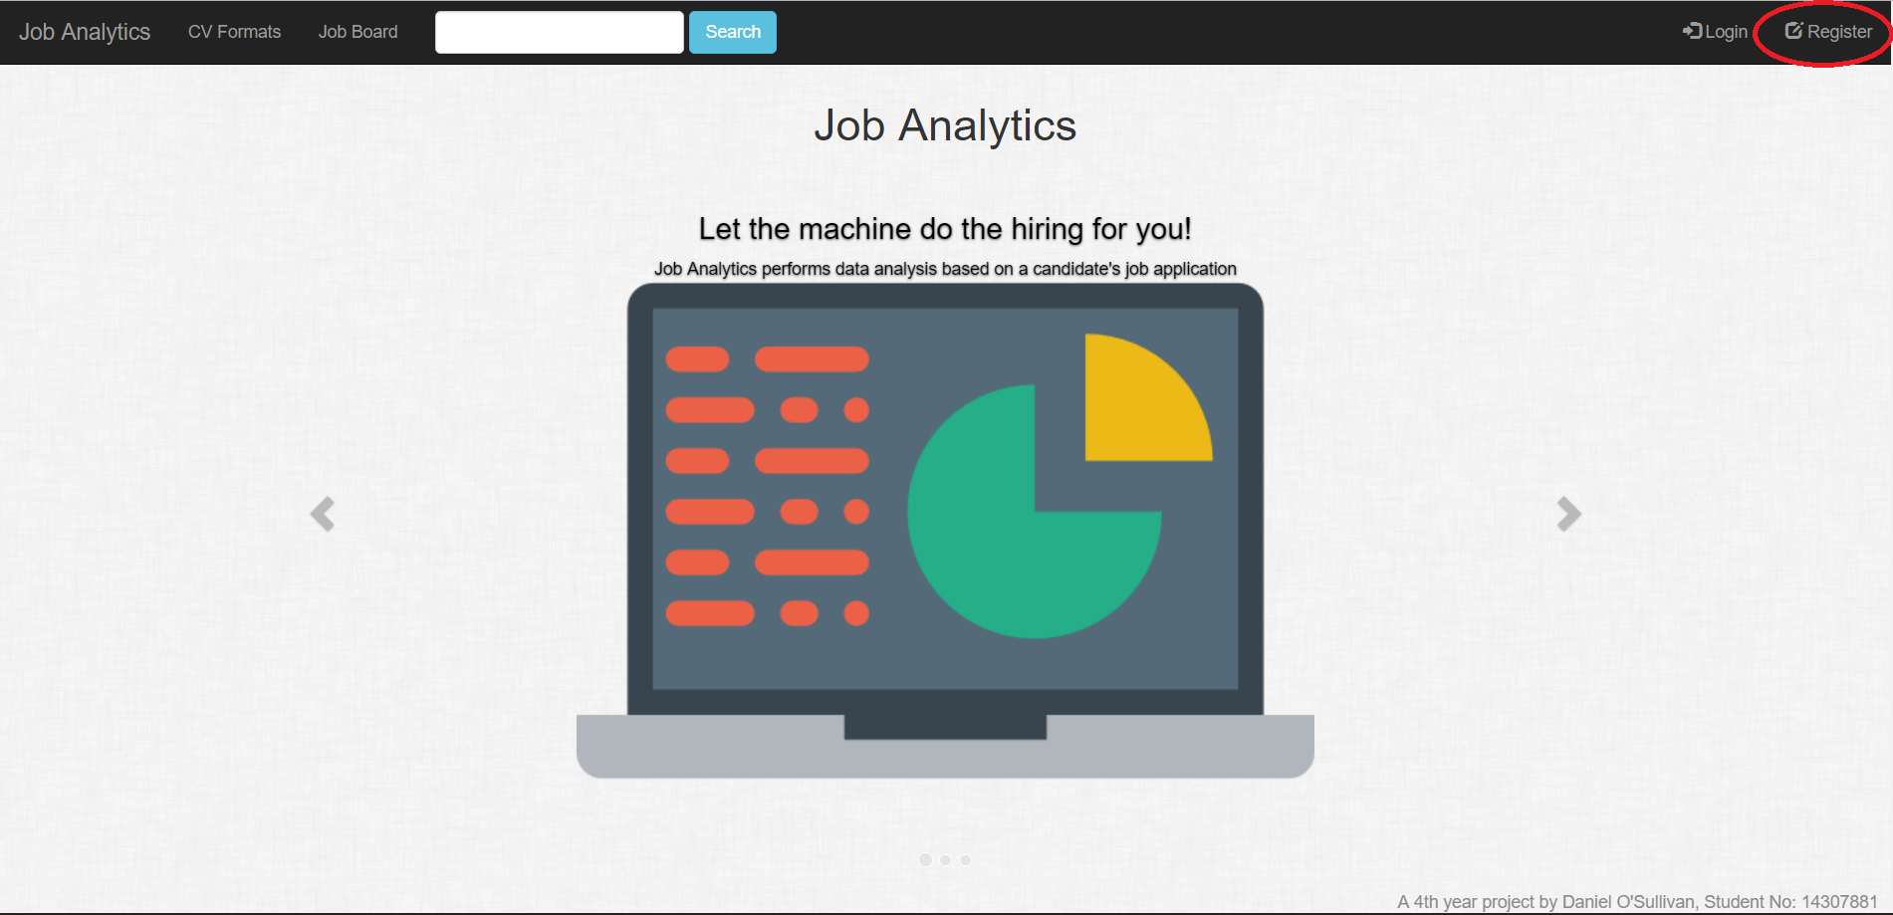

Once the page is loaded after clicking the register button, you should be presented with this page.

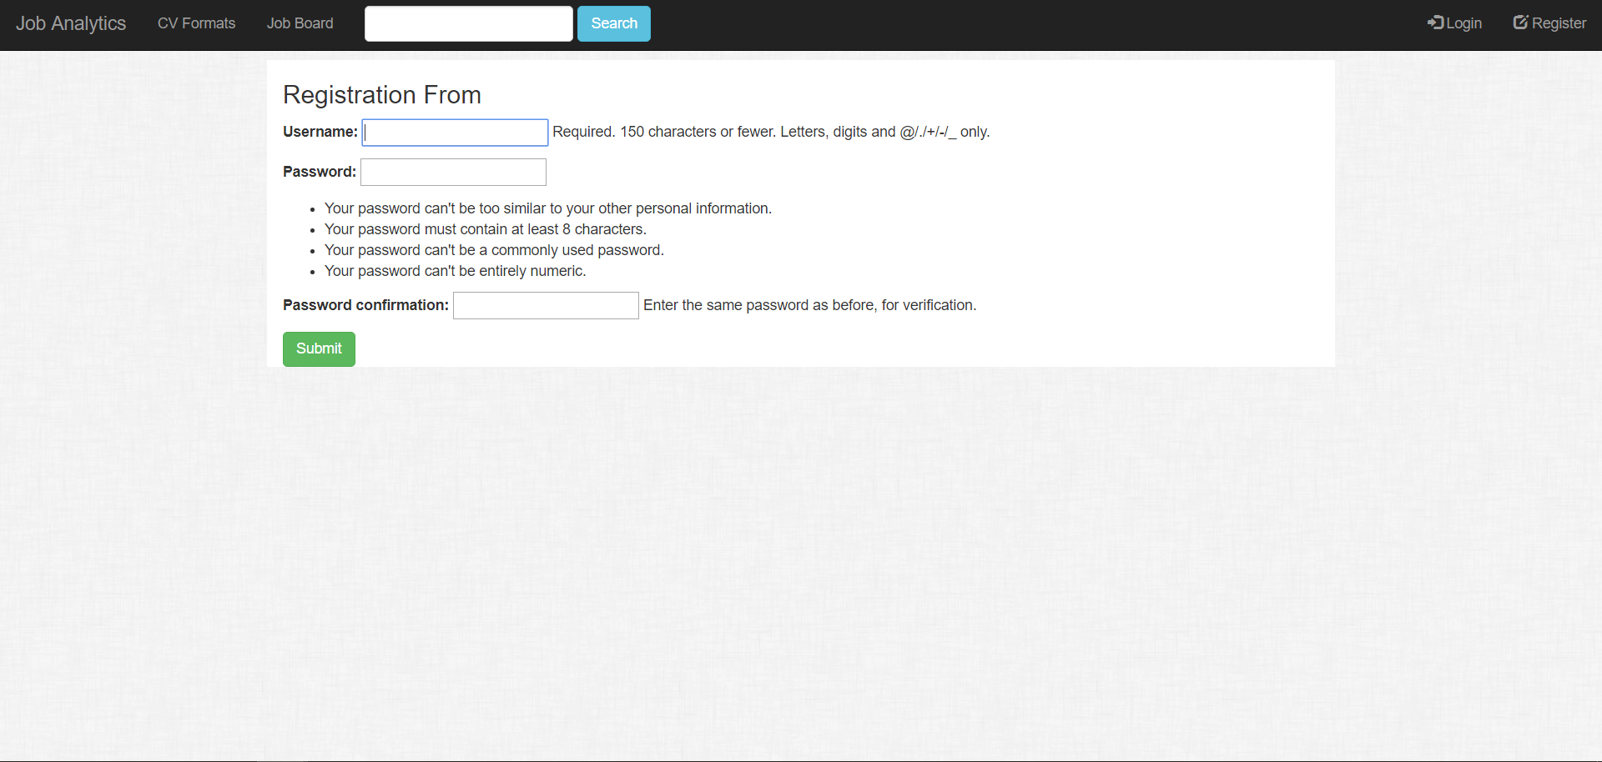

Follow the instructions on this page and fill out the registration form. Once you have filled out the form, click the green button labelled “Submit”, at the bottom of the form. You should then be redirected back to the homepage which is displaying a message indicating that you have successfully created a user and is now asking you to login.

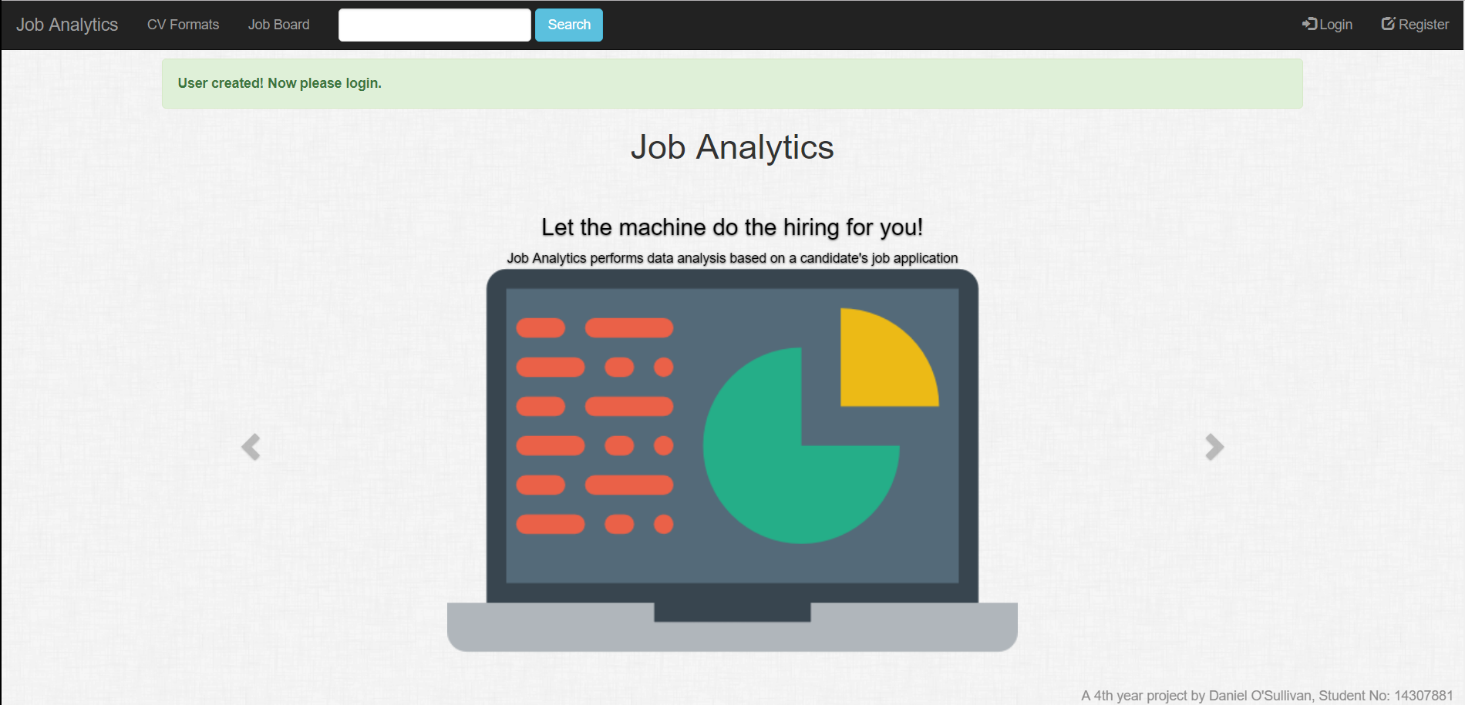

Logging In

To login with an existing user, click the button labelled “Login” displayed in the top right hand corner of the screen in the black navbar beside the button labelled “Register”.

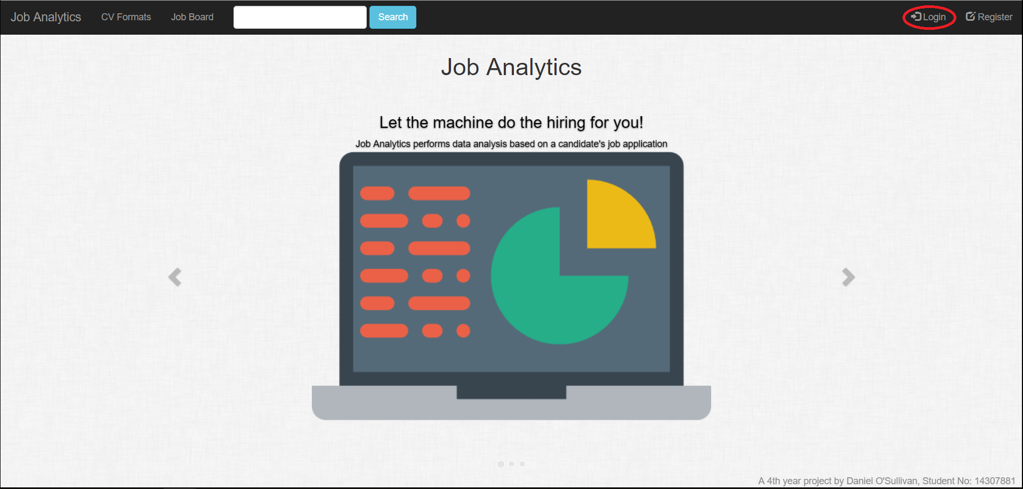

Once the page has loaded, you should be presented with this page.

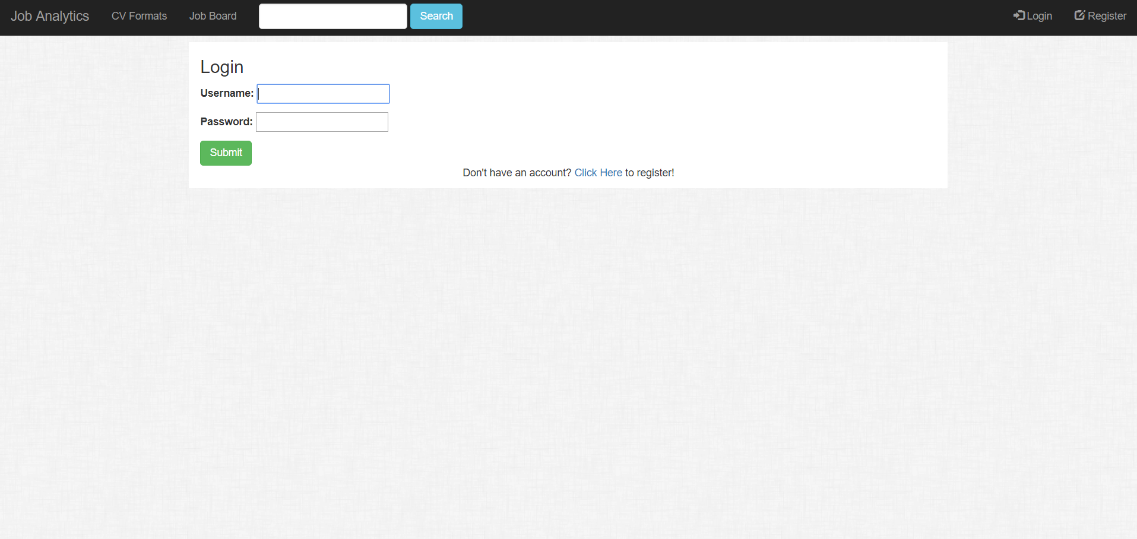

Please login by putting in your username and password. If you haven’t registered a user at this stage, you click the link at the bottom of the form labelled “Click Here”. This will take you to the registration page where you can register a user. Once you have completed filling out the login form, click the green button on the bottom of the form labelled “Submit”. You should be redirected to your user dashboard. This contains your username on top of a tablet titled “Your Posted Jobs”. The top right hand buttons labelled “Login” and “Register” should have changed to “Dashboard” and “Logout”.

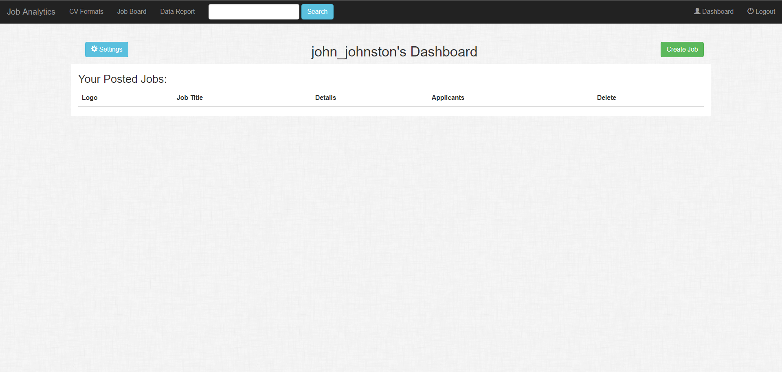

Posting a job

To post a job to Job Analytic,s navigate to your dashboard by clicking the “Dashboard” button located in the top right corner of the screen, beside the button that is labelled “Logout”. Once you are on your dashboard, click the green button labelled “Create Job” located in the near top right hand corner beside your dashboard title. 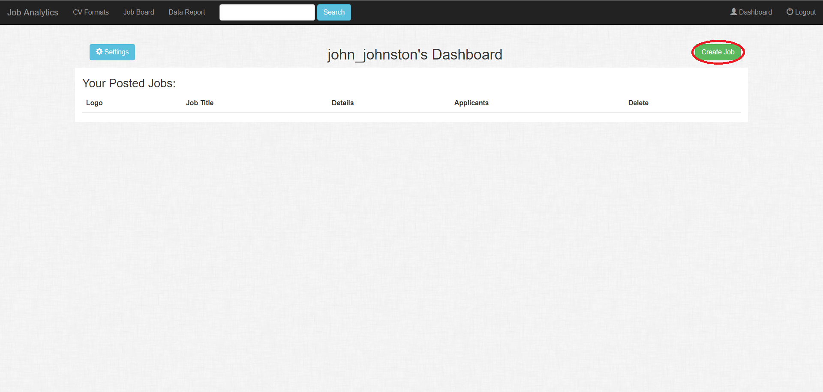

If you have posted jobs before, you will get a page similar looking to the one below. All the employers you posted as will appear on the screen. You can choose to post a job as one of these employers again or as a new employer.

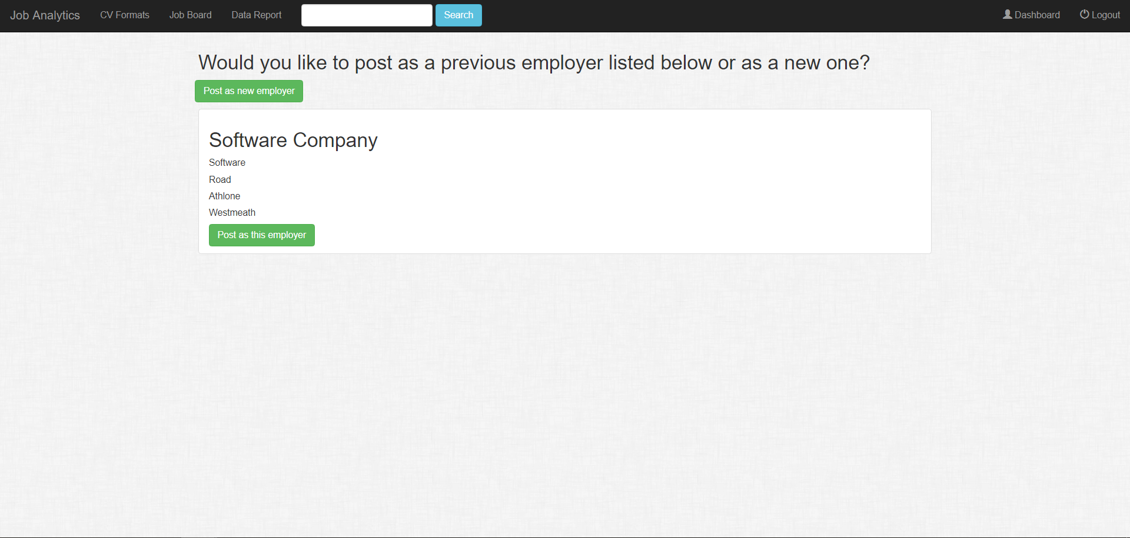

If it’s your first time posting a job, you will be redirected straight to the job posting form page.

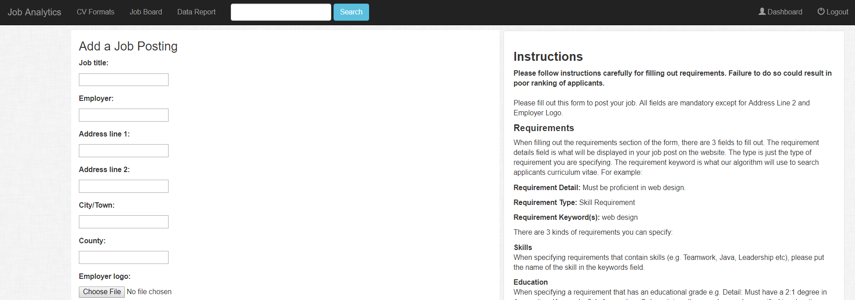

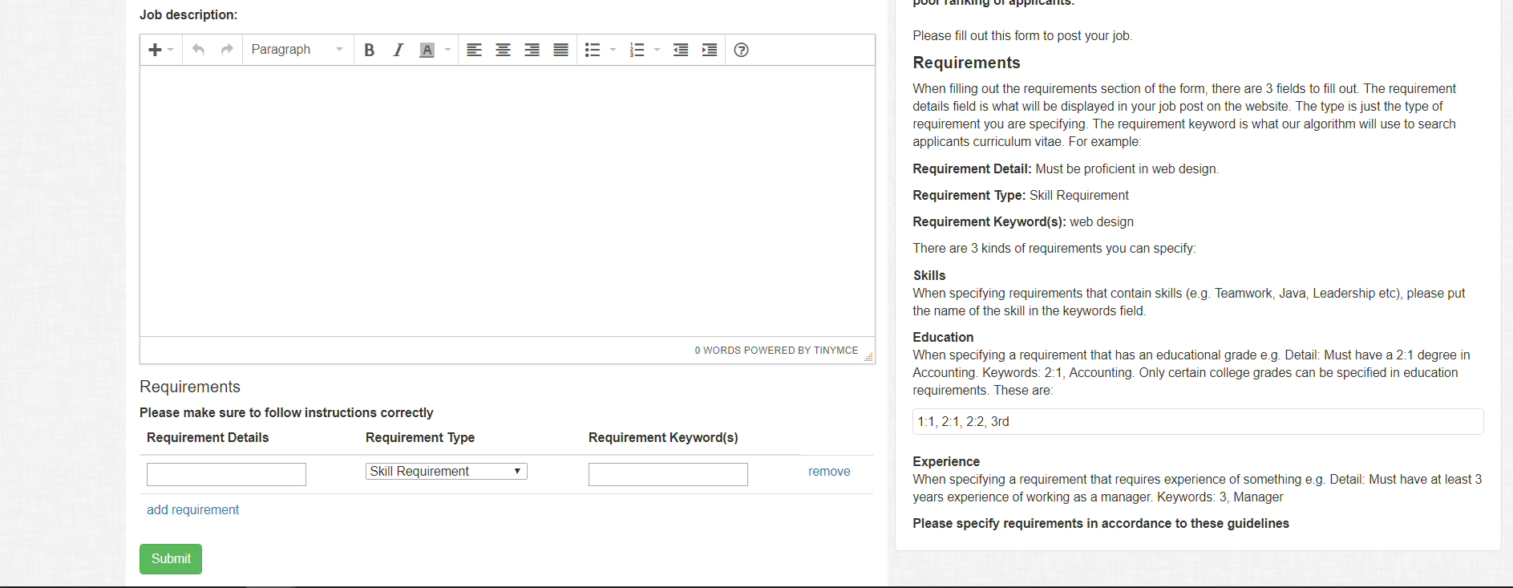

Here you fill out the information for your job posting. In order to post a job, you must supply the following information:

* Job Title
* Employer
* First address line of employer
* Second address line of employer (optional)
* City/Town of Employer
* County of Employer
* Employer Logo (if not specified sets a default image)
* Job Description
* Job Requirements

There are explicit instructions that you must follow for posting requirements. You specify requirement keywords in a very specific format. If you do not, this will result in errors in applicant matching scores and CV summaries. There are 3 kinds of requirements you can specify:

**Skill Requirements**

These are requirements for applicant work skills e.g Java, Leadership, Photoshop etc. You must specify one skill per requirement. In the requirement keyword section, specify the word or words that will be searched for in the CV by the parser.

Example of a skill requirement:

**Requirement Details:** Must be know JavaScript.

**Requirement Type:** Skill Requirement

**Requirement Keyword(s):** JavaScript

**Education Requirements**

These are requirements that search for educational standard in an applicant e.g. Must have a 2:1 degree in Culinary Arts. For college grades like the one in this example, we have implemented that only one kind of college grading system be accepted in requirements. The college grades that are allowed to be specified are:

* **1:1** (70% - 100%)
* **2:1** (60% - 70%)
* **2:2** (50% - 60%)
* **3rd** (40% - 50%)

Education requirements are not only limited to college grades. Secondary grades such as leaving certificate points, can also be specified. When specifying requirement keywords, you must do so in the following format:

**Grade, Degree/Exam**

Example of an education requirement:

**Requirement Details:** Must have obtained a minimum of 365 points in the Leaving Certificate

**Requirement Type:** Education Requirement

**Requirement Keyword(s):** 435, Leaving Certificate

Another example of an education requirement:

**Requirement Details:** Must have a 3rd grade degree in Multimedia

**Requirement Type:** Education Requirement

**Requirement Keyword(s):** 3rd, Multimedia

**Experience Requirement**

These are requirements for work experience. This could be a requirement for experience with a specific software or item e.g. must have 2 years experience using Microsoft Excel, or experience in a certain role or position e.g. must have 3 years experience of being a software developer. You must specify a time frame for the experience and it must be in years. It is must be specified in the following format:

**Years, Experience item/role**

Example of an experience requirement:

**Requirement Details:** Must have 4 years experience as a Civil Servant

**Requirement Type:** Experience Requirement

**Requirement Keyword(s):** 4, Civil Servant

You can specify as many requirements as you want by clicking the “add requirement” text at the bottom of the job posting form. If you want to remove a requirement, click the text labelled “Remove” beside the requirement you want to remove. If you want to post a job with no requirements specified, just remove all requirements before you submit the form.

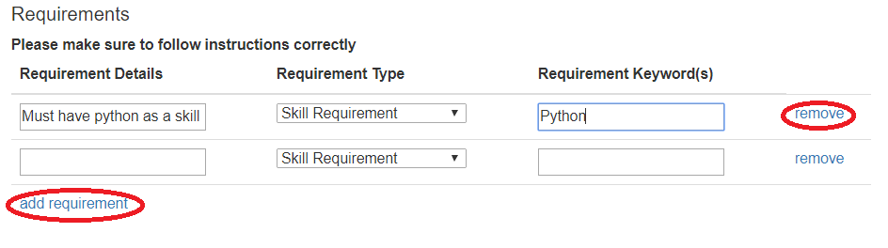

After you have filled out all the fields in the job posting from, as well as requirements, please make sure everything you inputted is correct (especially for requirements). After you have checked everything, scroll down to the bottom of the page and click the green button labelled “Submit”. You will be redirected to the job board page and a banner stating that you have successfully posted the job should be present. You should be able to view the posted job in your user dashboard.

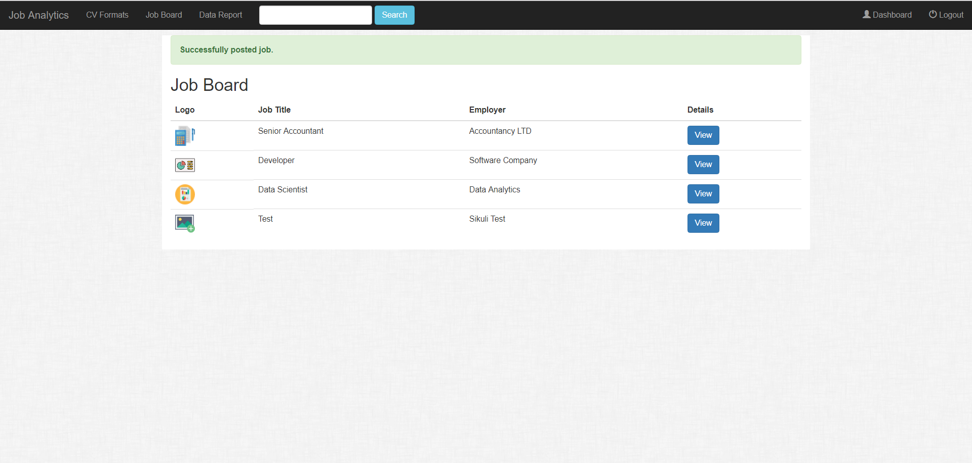

Viewing Applicants

To view the applicants that have applied for you job post, navigate to your user dashboard. Click the blue button labelled “View” in the row of the job posting you are interested in, underneath the “Applicants” header.

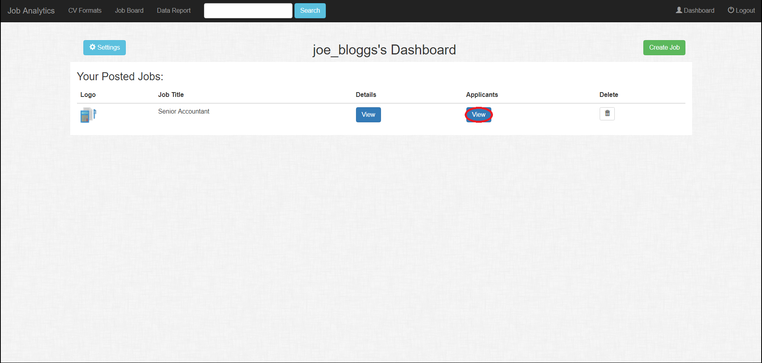

Clicking the button should take you to a page that looks similar to this.

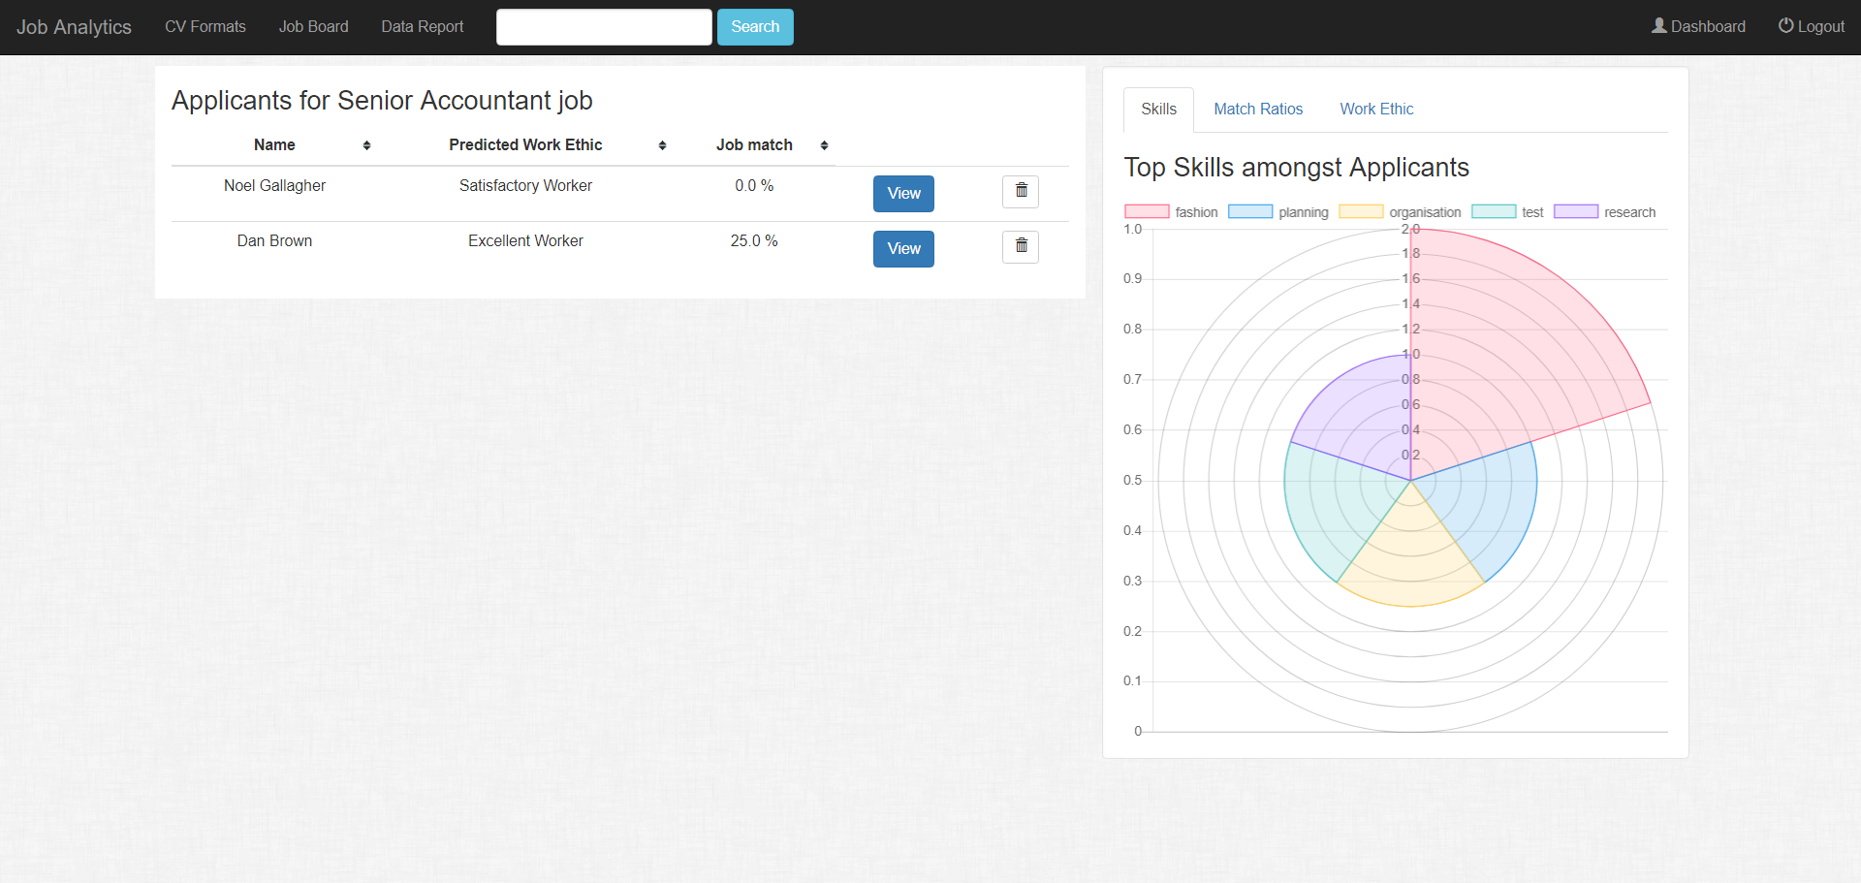

Here you will see the list of applicants who have applied for your job post. In the list, you will see the applicant’s predicted work ethic and their job match score. Clicking the table headings will sort the table based on the column heading you are clicking e.g. if you want sort the applicants by job matching score, click the heading labelled “Job Match”. The graphs displayed on the right hand side of the page show data related to all the applicants that have applied for your job post. There are 3 graphs:

* A polar area graph that shows the top skills amongst the applicants
* A pie chart that shows the distribution of match scores amongst the applicants
* A doughnut area graph that shows the distribution of predicted work ethic scores amongst the applicants

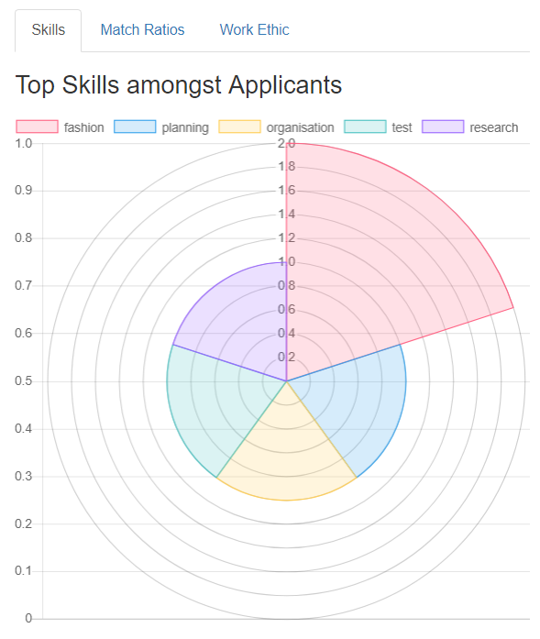 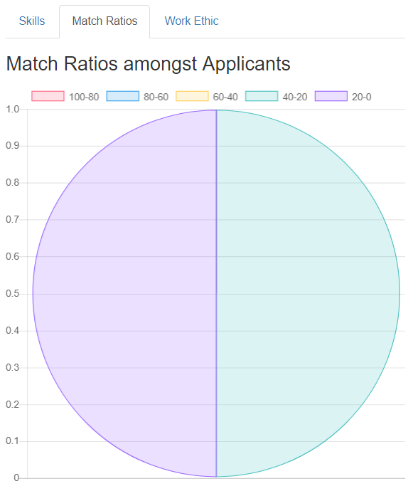

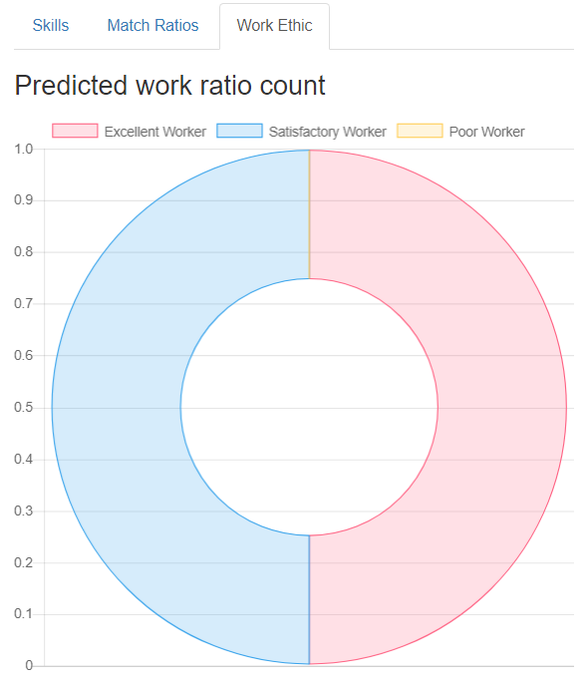

If you want to view an applicant’s summary, click on the blue button labelled “View” in the row of the applicant you are interested in.

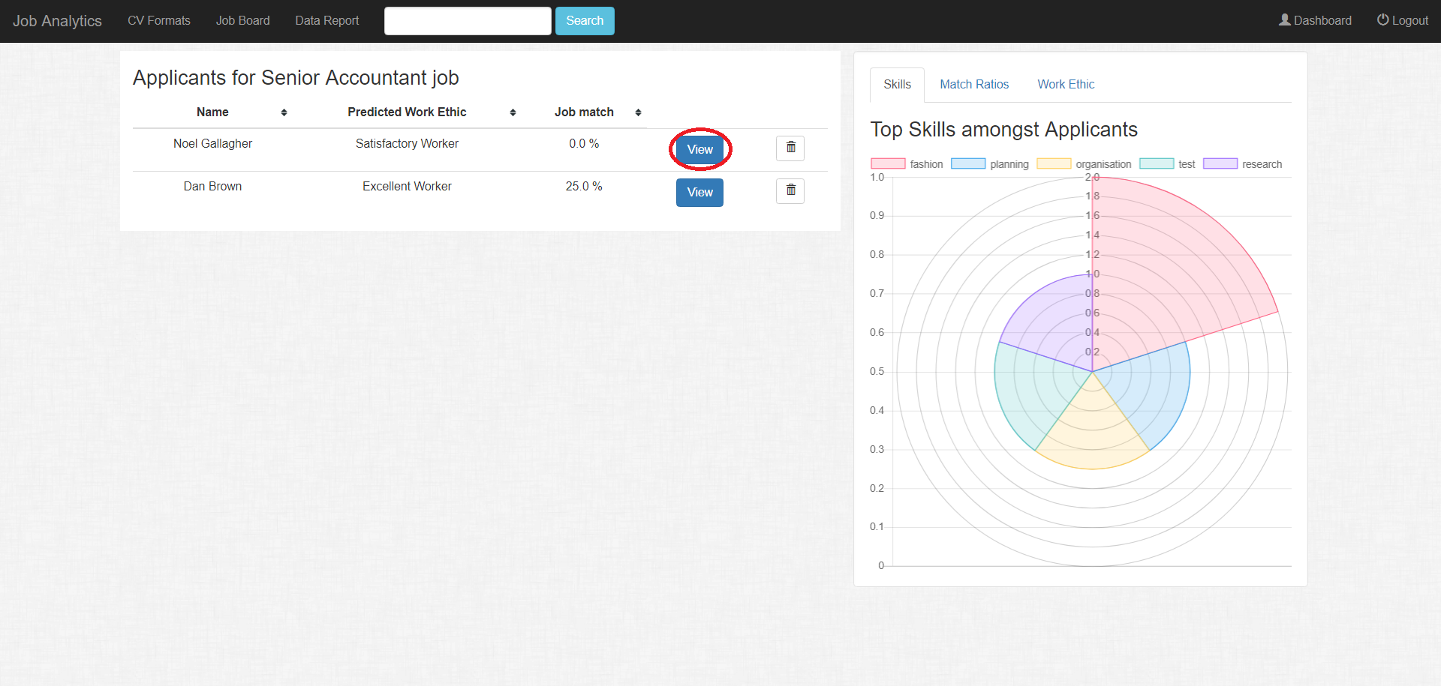

This will take you the applicant’s summary page. On the right hand side is the applicant’s summary. On the left hand side is the contents of the applicant’s CV. In the summary you can see:

* The requirements the applicant matches and doesn’t matches
* Their predicted work ethic
* Their education history
* Their work history
* Their skills

You can choose what way to view the applicant’s curriculum vitae. You can display it in a neat formatted style using information extracted from the CV using our CV parser. Or you can view the curriculum vitae contents exactly the way they were uploaded. No customisation has been done to make the CV look more pleasant if you choose the latter option. We did this so if you don’t trust our summaries and scores, you can read the curriculum vitae yourself and make your own judgements.

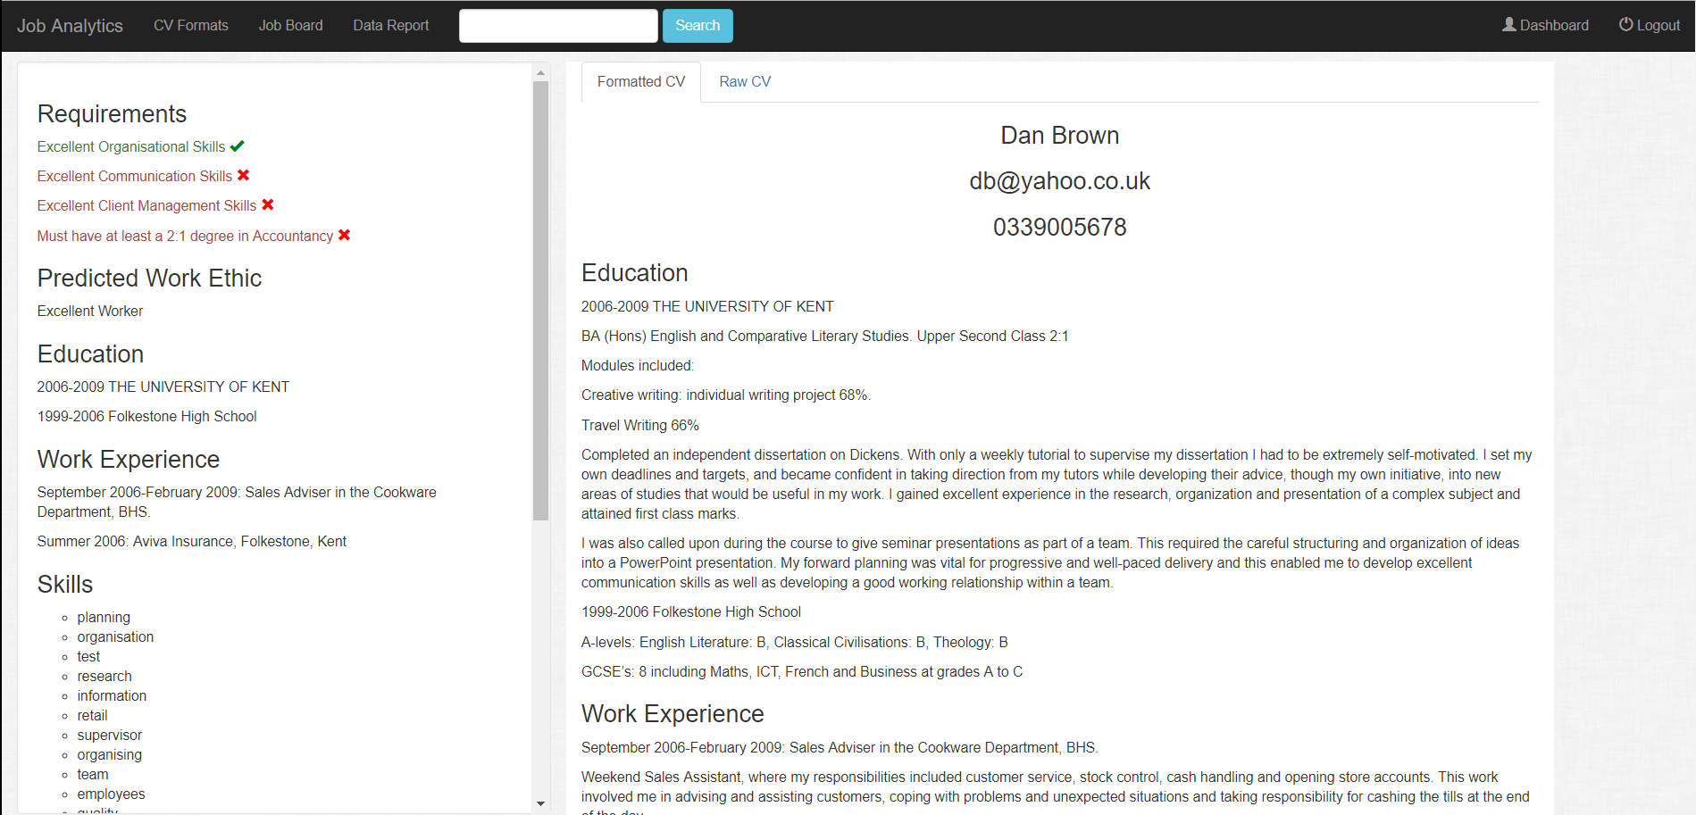

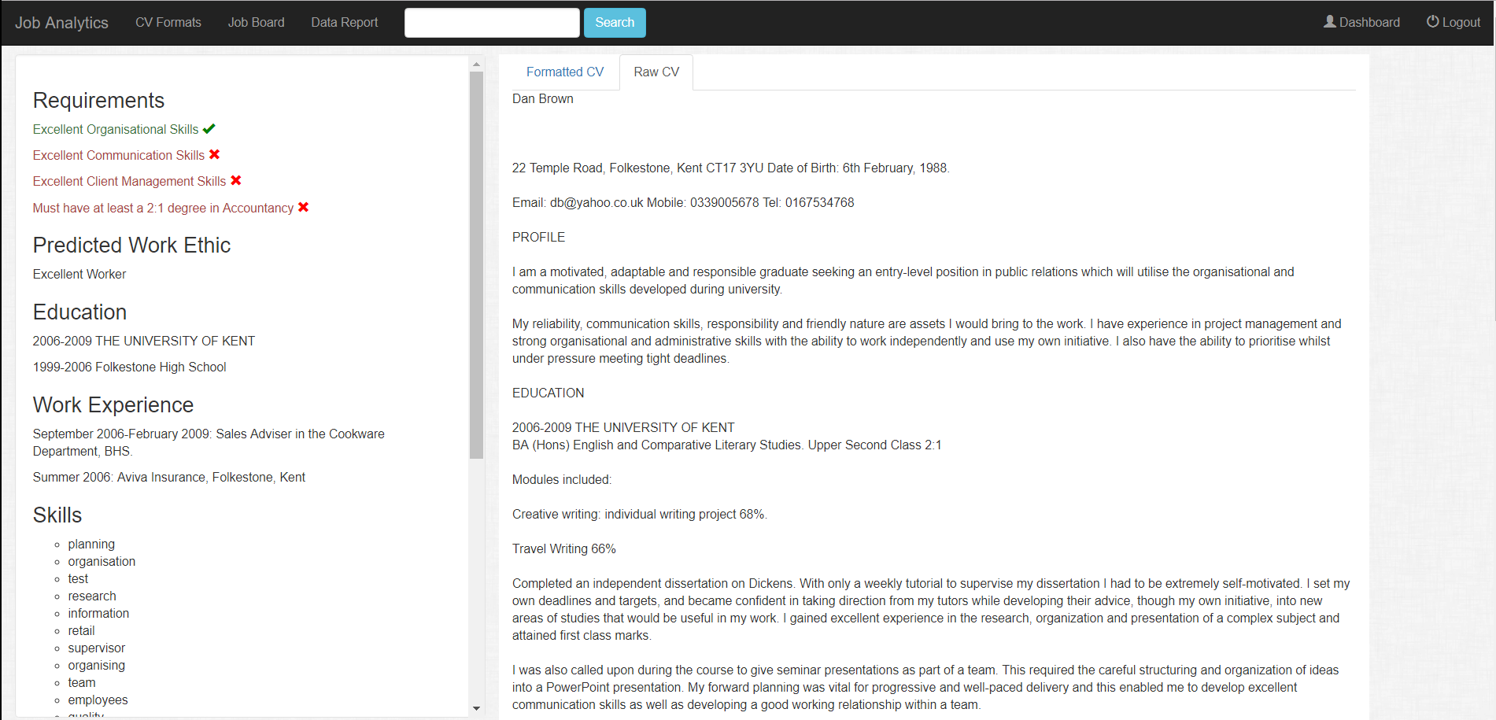

Updating a job

If you want to update job posting, first navigate to your dashboard. Click the blue button labelled “View” in the row of the job posting you are interested in changing, underneath the “Details” header.

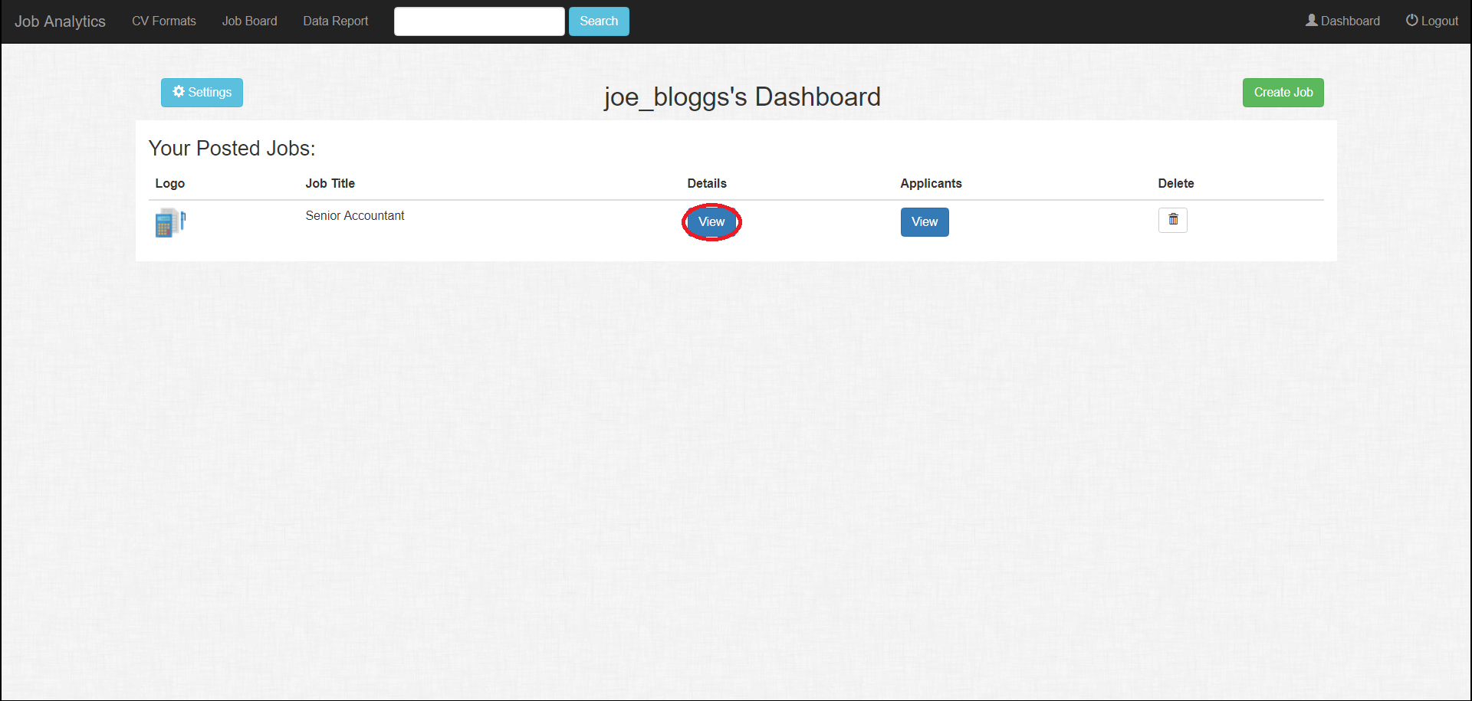

You will be redirected to that job information page. Scroll down to the bottom of the page and click the blue button labelled “Edit Details”.

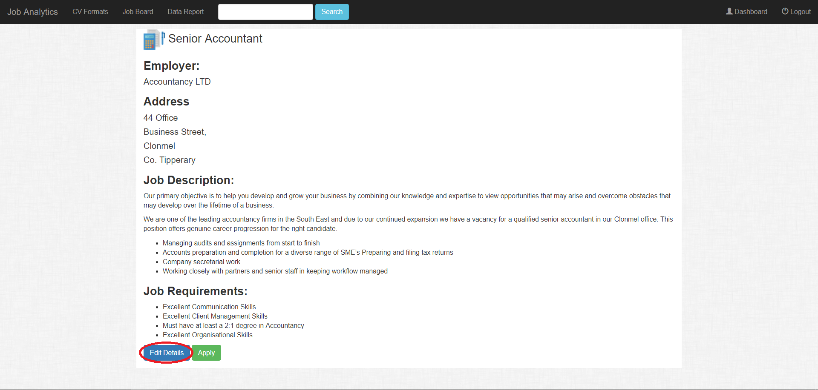

You will then be redirected to the job posting form but with the existing details of the job already filled out. Change which fields you want to change and then click the submit button. Don’t forget to check requirement specifications!

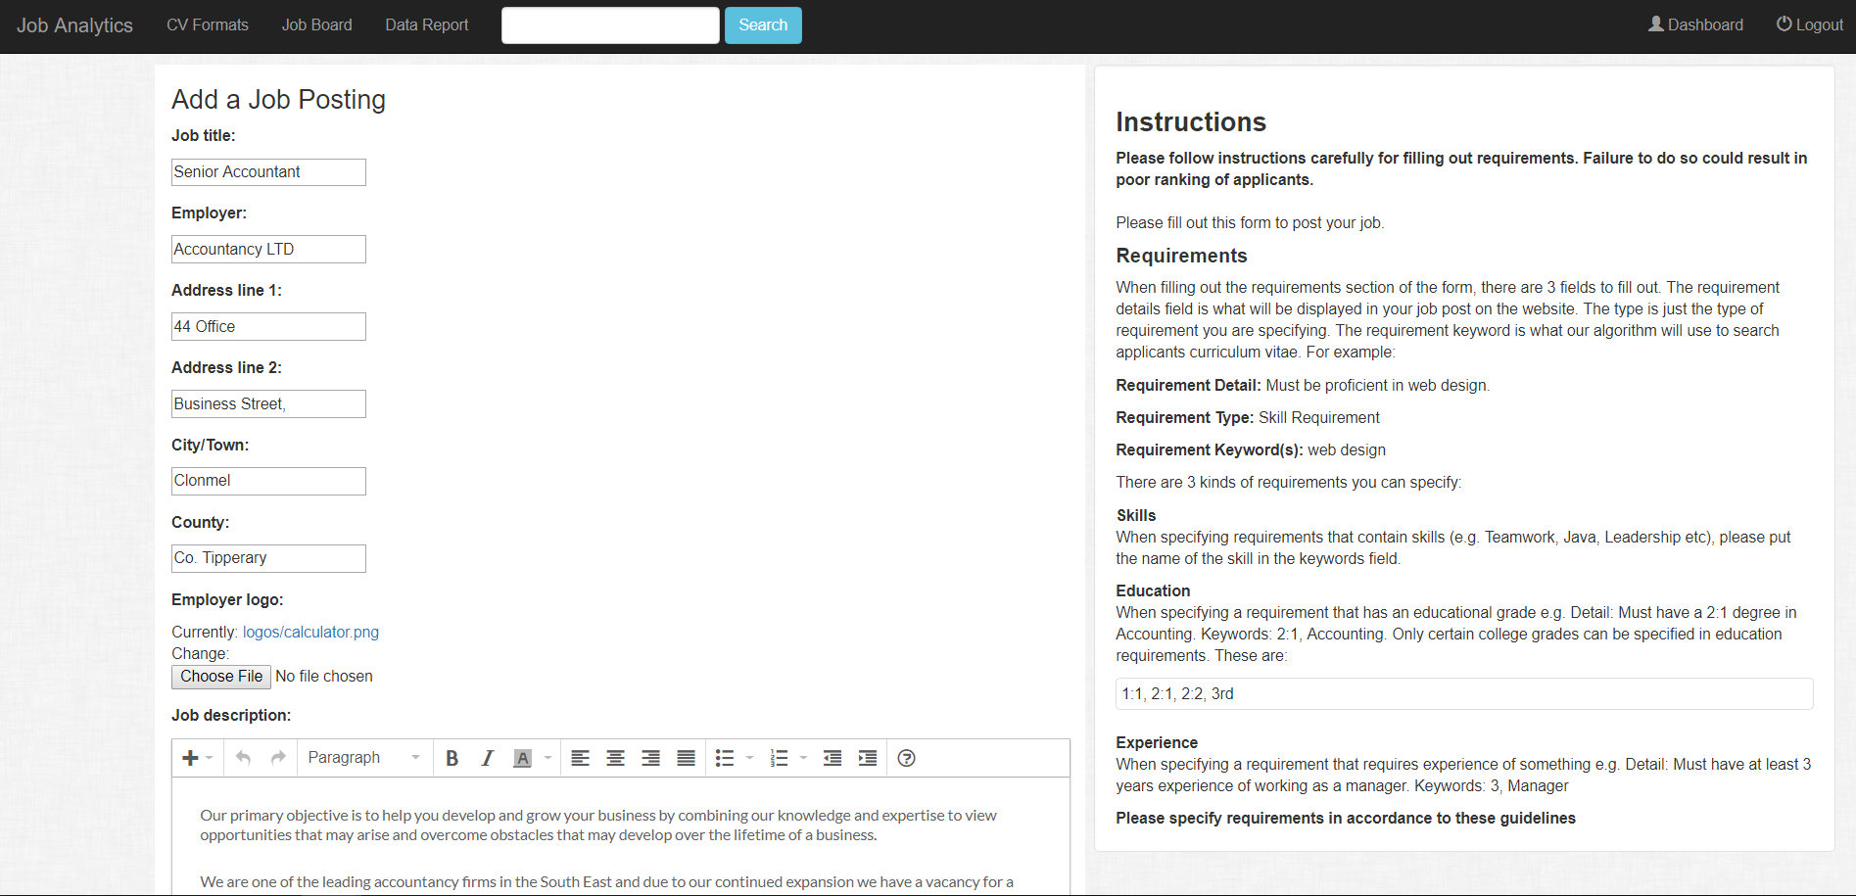

Deleting a job

To delete one of your job postings, navigate to your user dashboard. Click the trash icon underneath the “Delete” heading in the row of the job you want to delete.

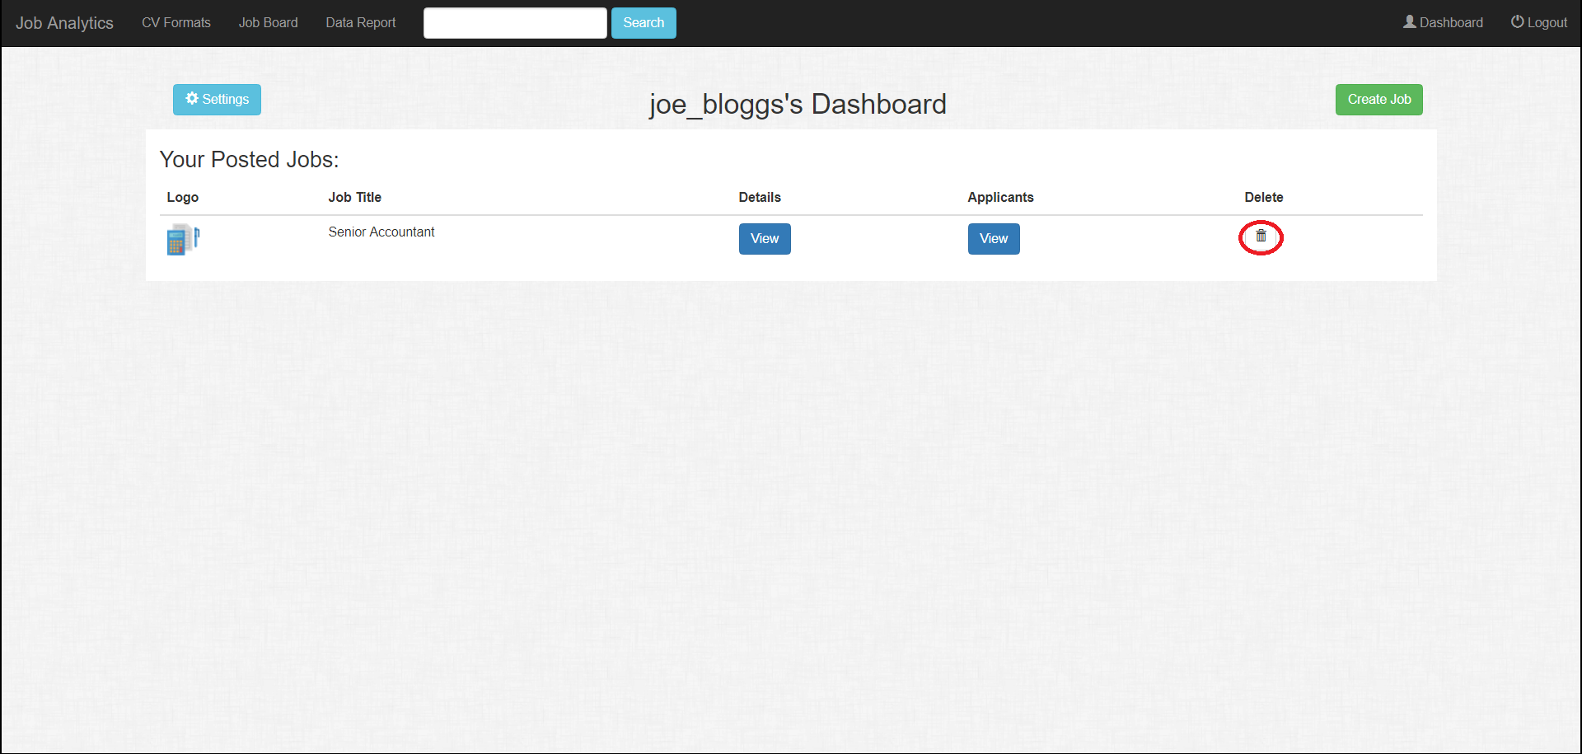

Once you click the icon, you will be redirected to a page that looks similar to this.

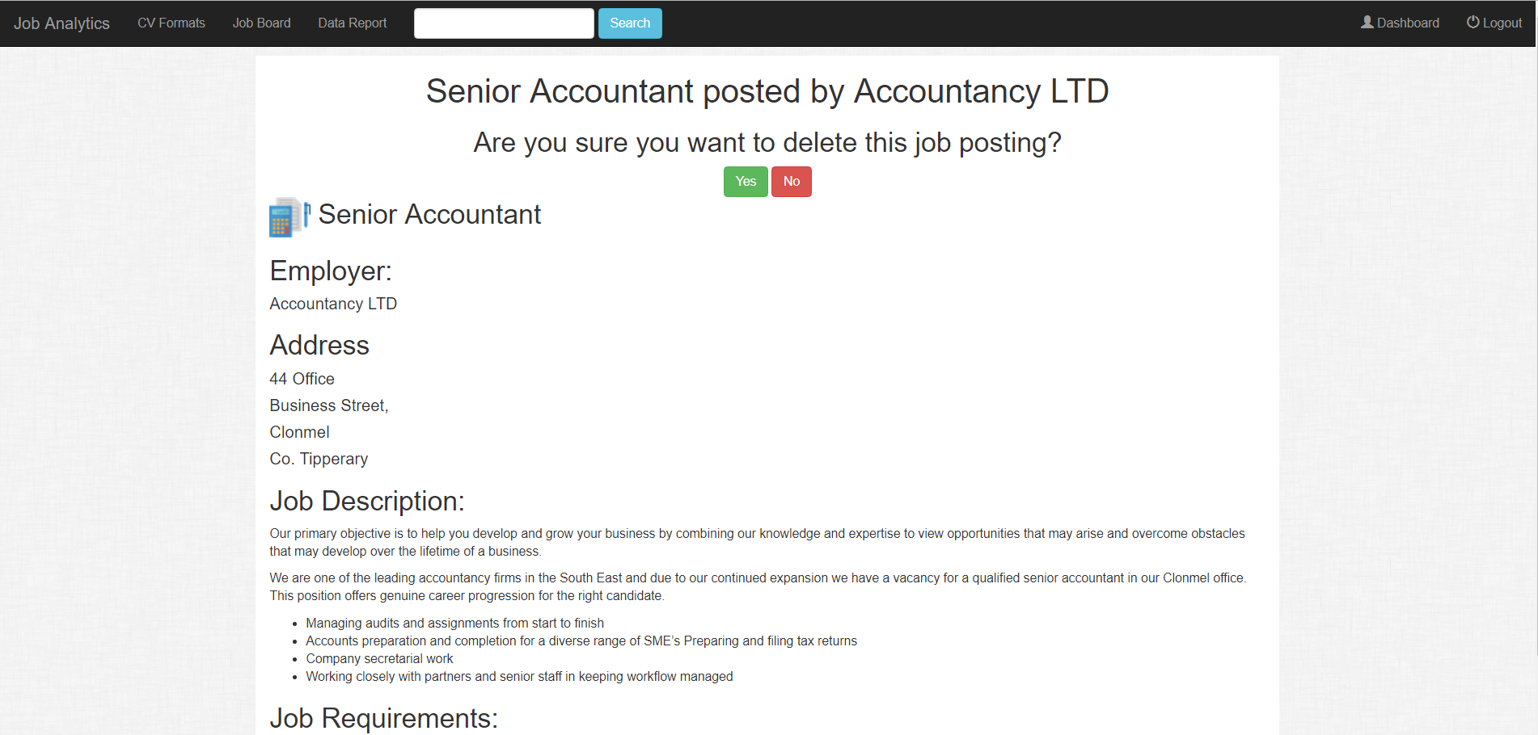

If you select the green button labelled “Yes”, the job posting will be deleted. If you select the red button labelled “No”, the job posting will not be deleted. Either decision you make will redirect you back to your dashboard. Note that deleting a job posting will in turn delete all it’s applicants.

Deleting an applicant

To view your applicants for your job post, navigate to your user dashboard. Click the blue button labelled “View” in the row of the job posting you are interested in underneath the “Applicants” header.

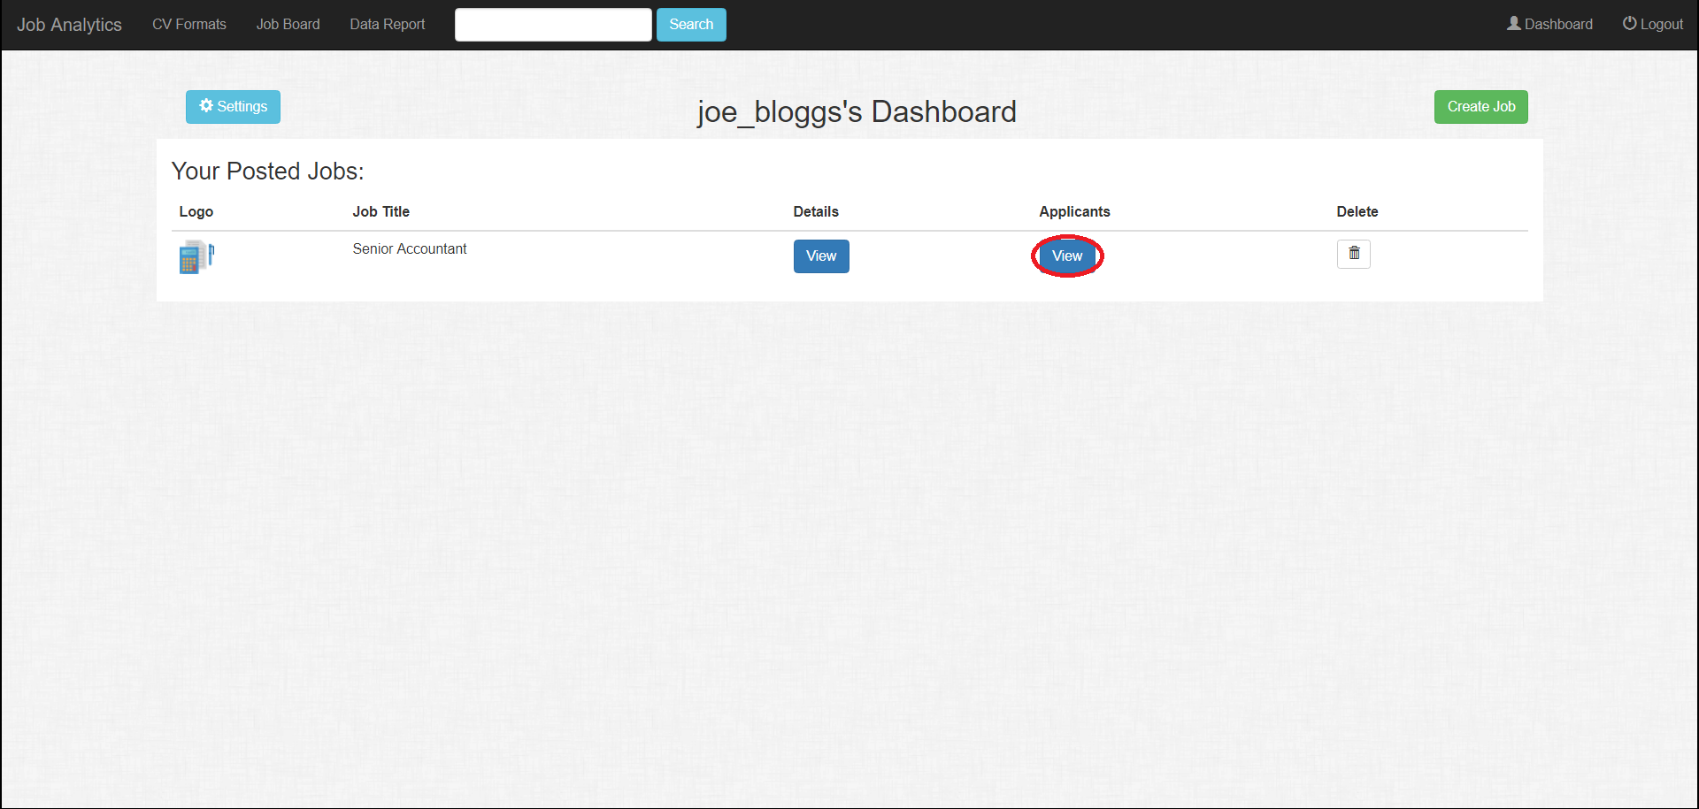

Once you get to the applicant list page, click the trash icon in the row of the applicant you want to delete.

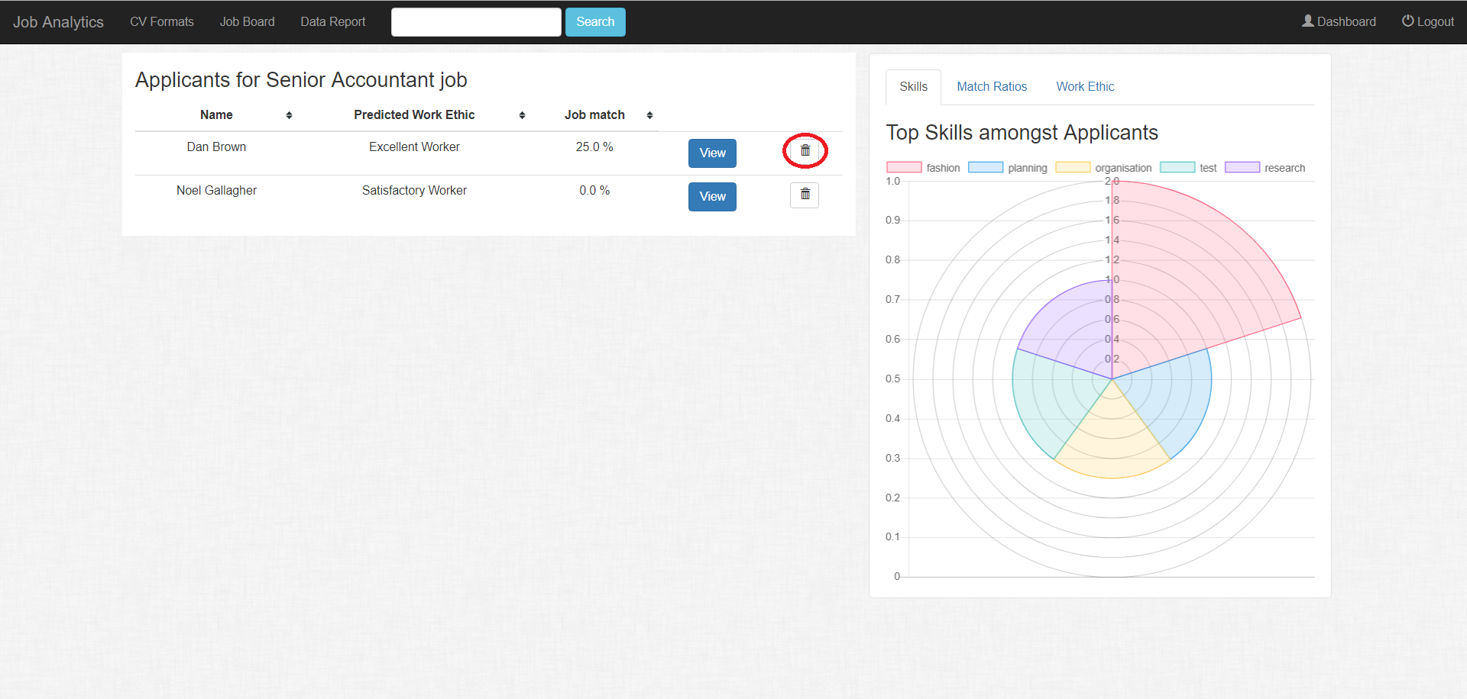

Once you click the icon, you will be redirected to a page that looks similar to this.

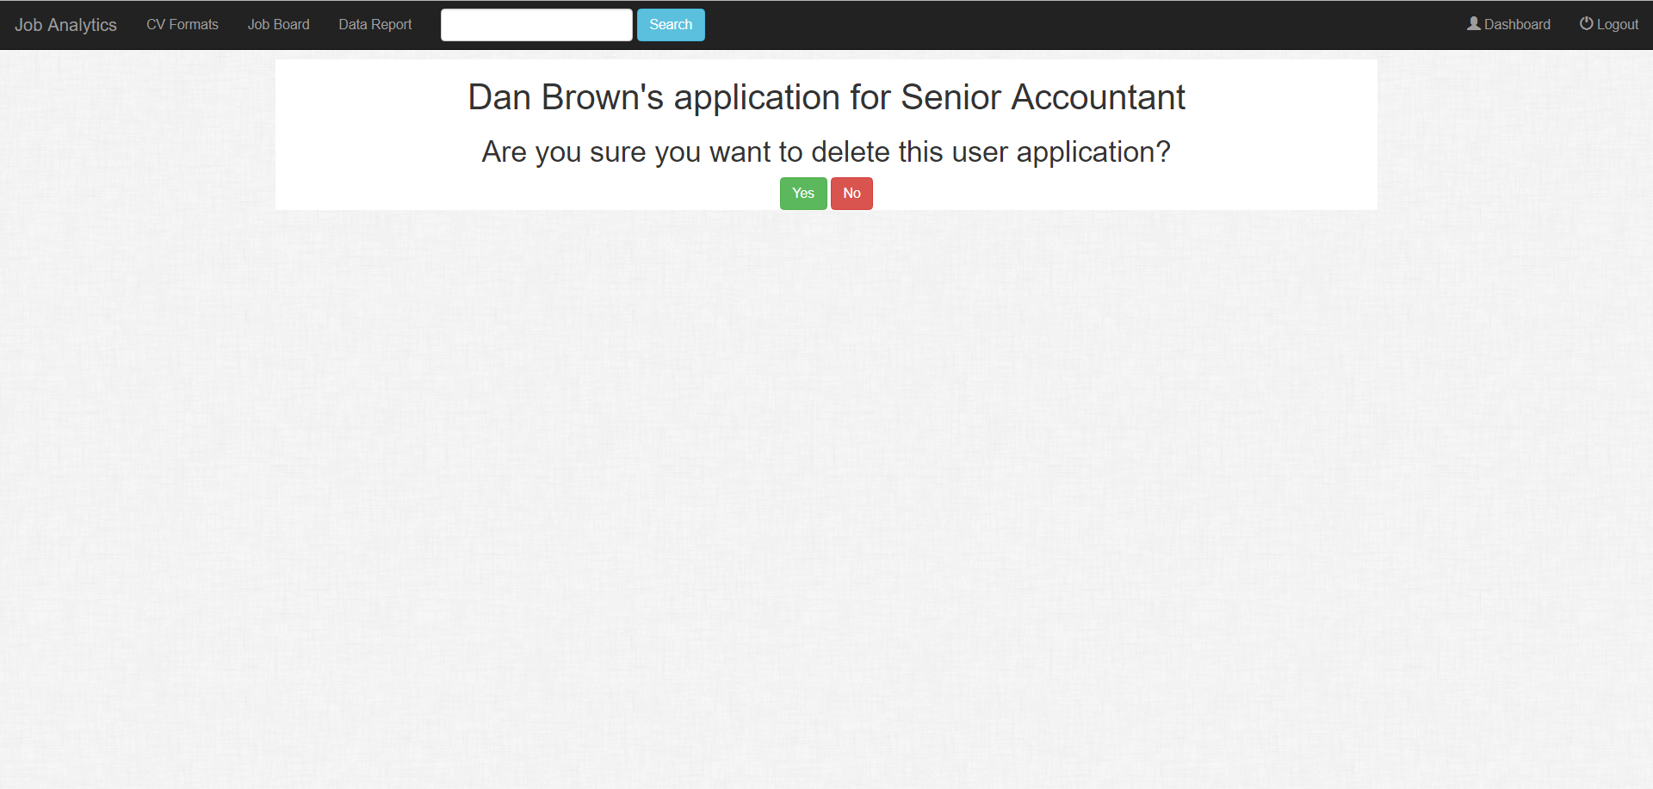

If you select the green button labelled “Yes”, the applicant will be deleted. If you select the red button labelled “No”, the applicant will not be deleted. Either decision you make will redirect you back to the applicant list for that job.

Deleting your user account

If you wish to delete your user account, first you must navigate to your user dashboard. Click the light blue button labelled “Settings” near the top left hand corner of the page to the left of your dashboard heading with you username.

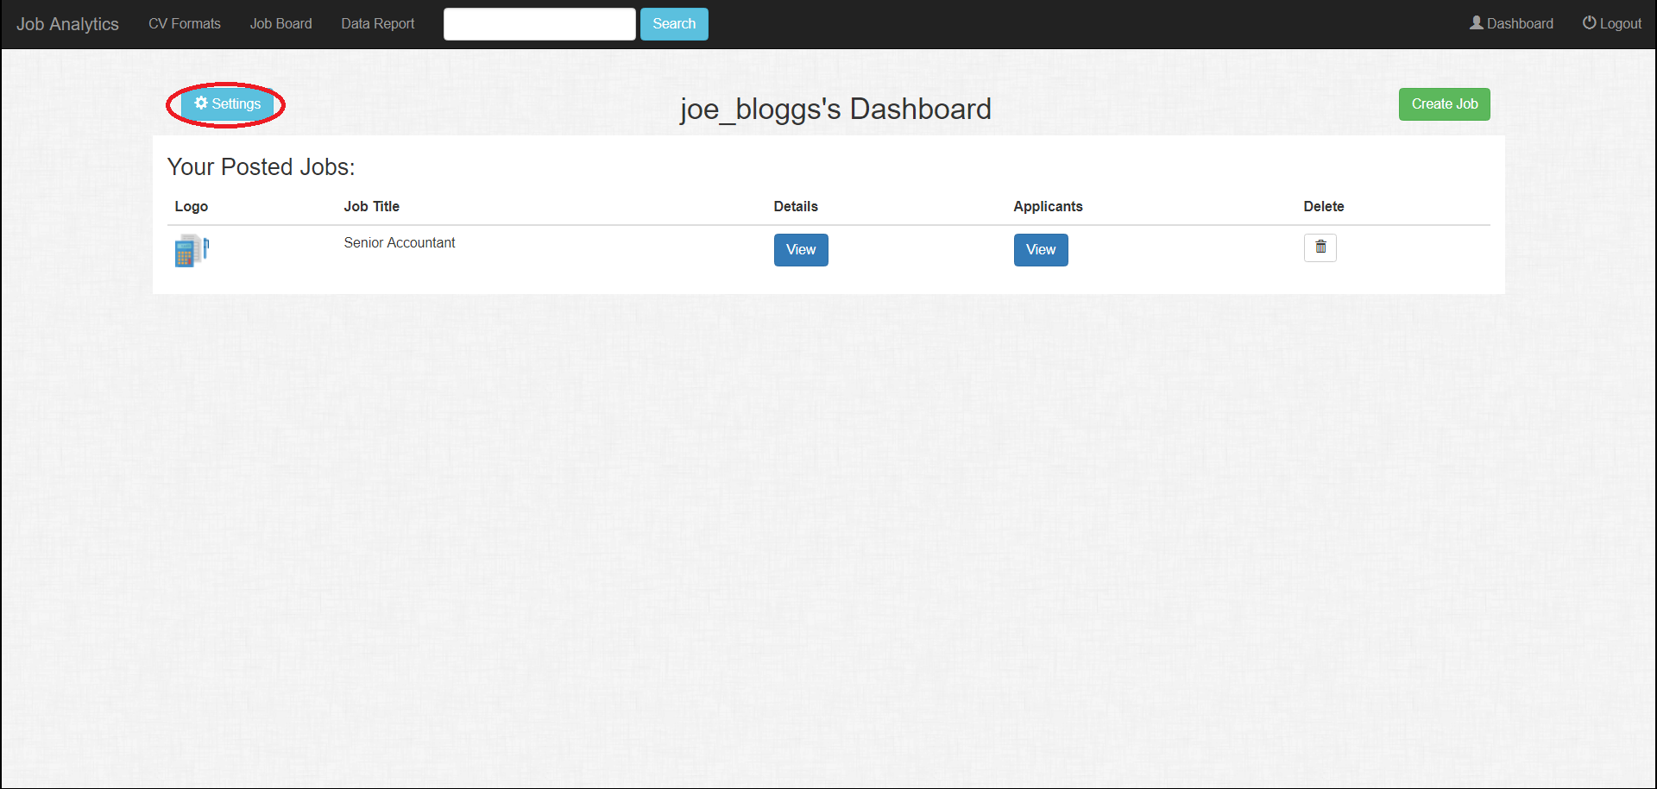

A slide out panel should appear from the left hand side of the page. Click the red button labelled “Delete Account” in the slide out panel.

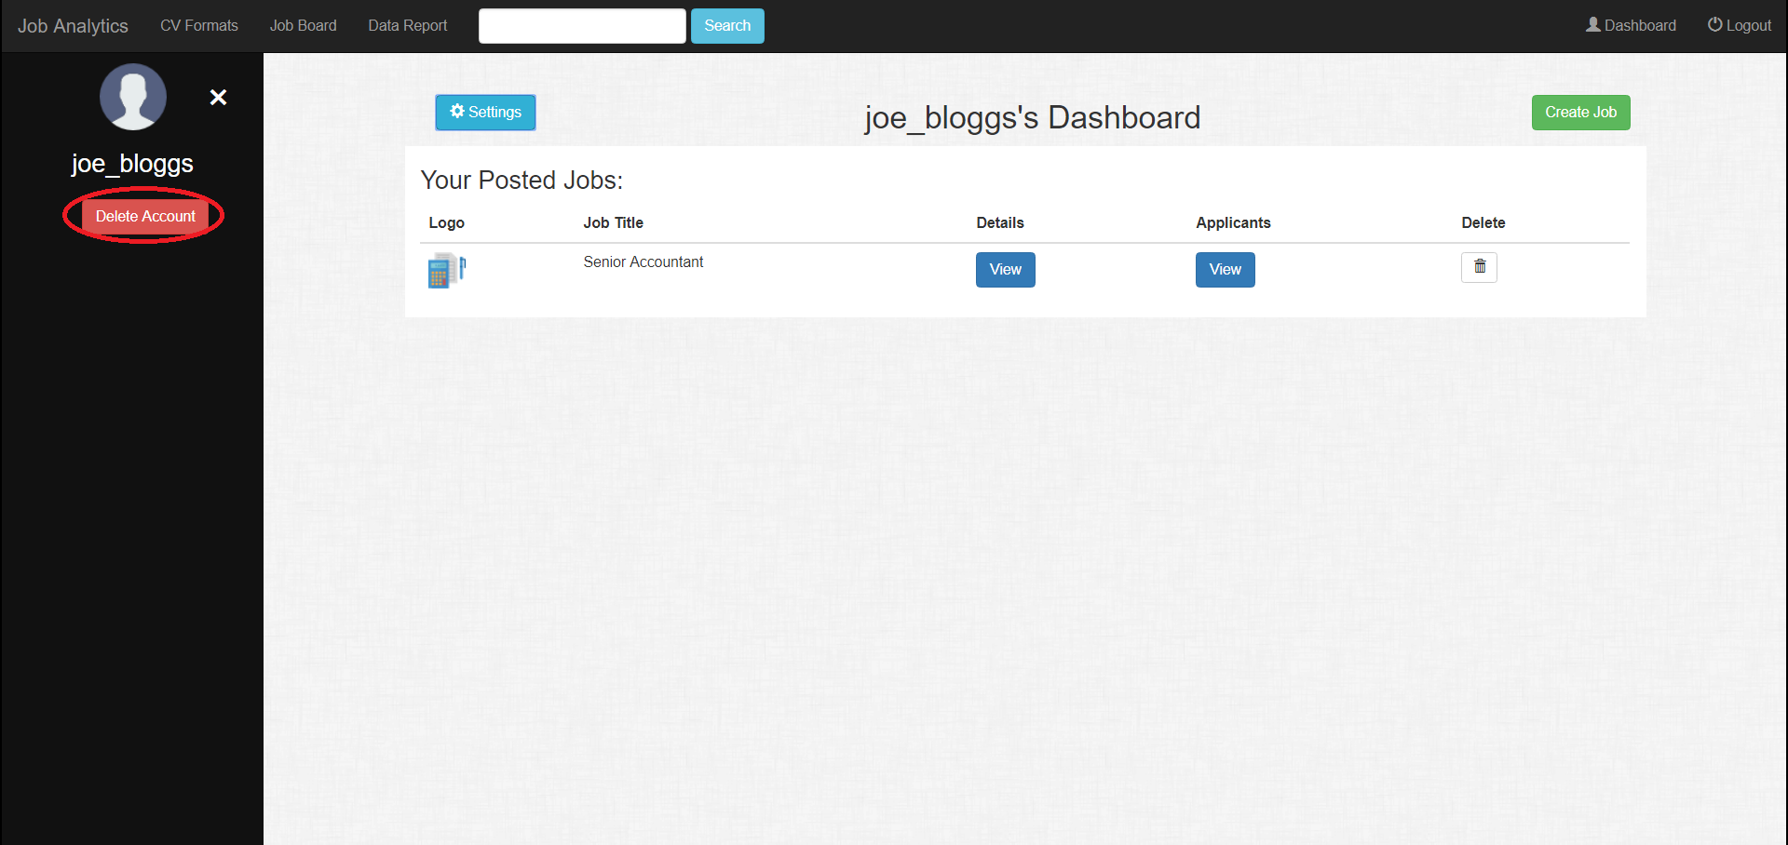

After you have clicked the button, you should be redirected to a page similar looking to the one below.

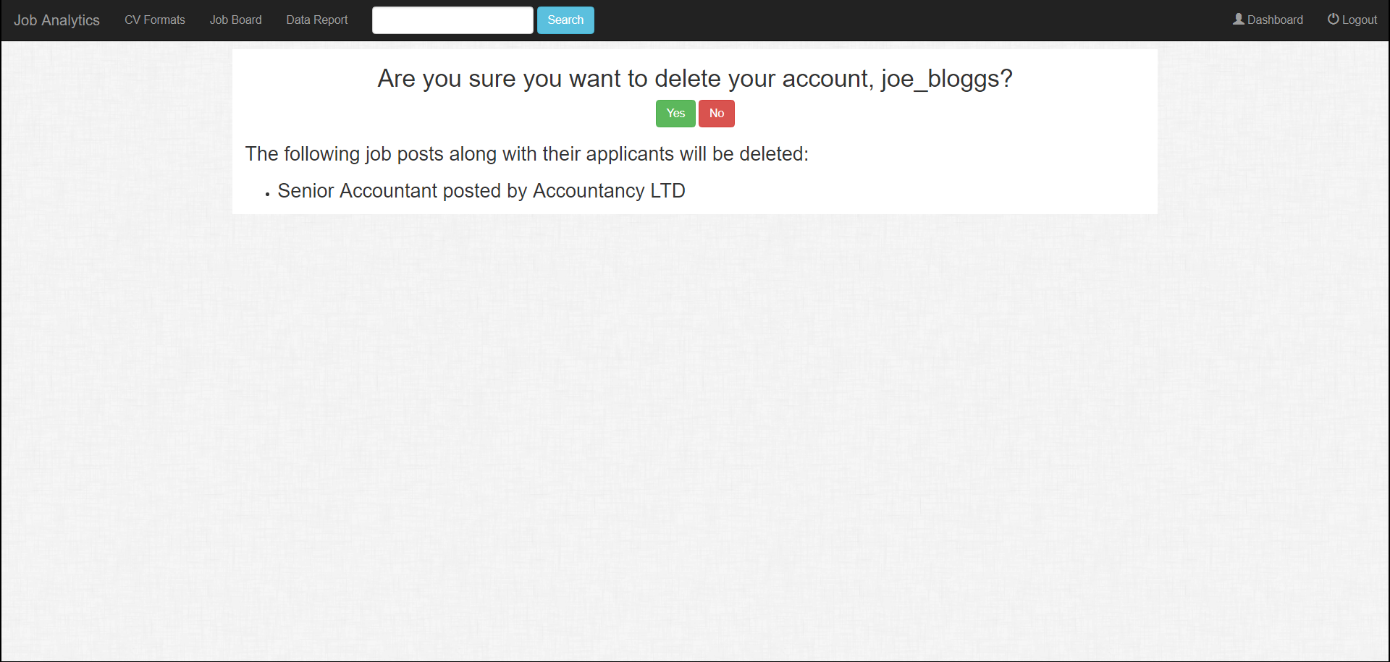

If you click the green button labelled “Yes”, your account will be deleted and you will be redirected back to the homepage of the application. Note that deleting your account will in turn delete all your posted jobs along with their applicants. If you click the red button labelled “No”, you will be redirected back to your user dashboard.

Applicant

Searching for a job

To search for a job, use the search bar located on the top of the screen in the navigation bar. This search bar will appear on every page in the application. The application searches jobs by job title. Type in a query relating to a job title that you are interested in.

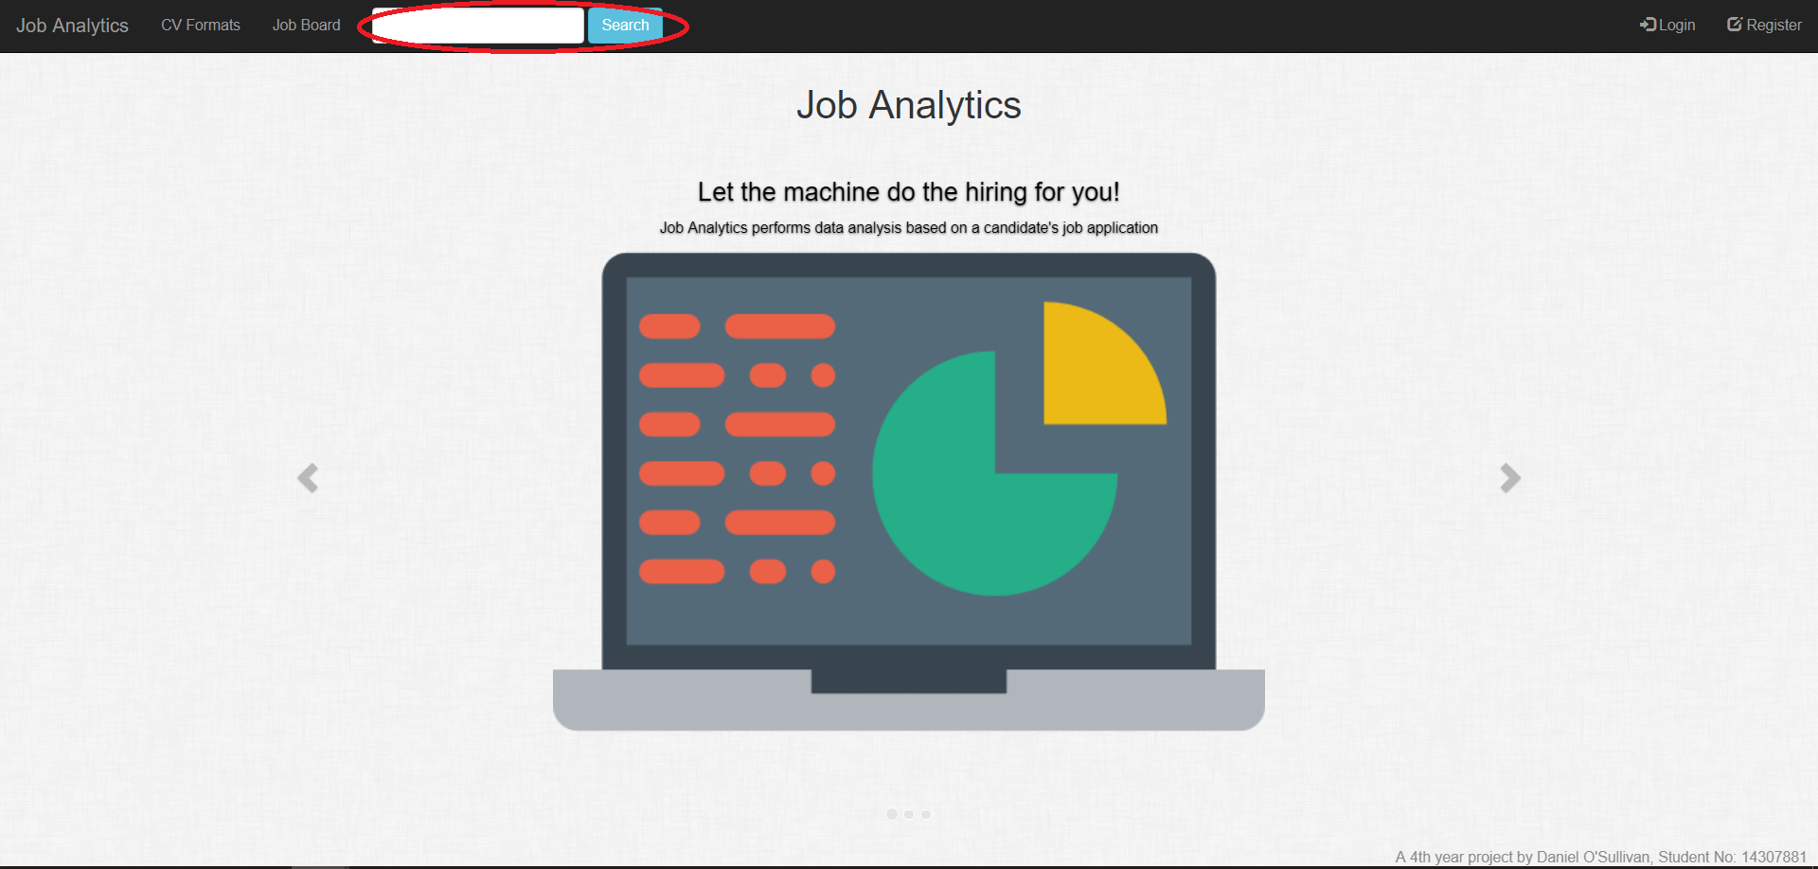

After you have typed in your search query in the search bar, click the light blue button beside it labelled “Search”. This will redirect you to the job board but only jobs matching your query will be shown.

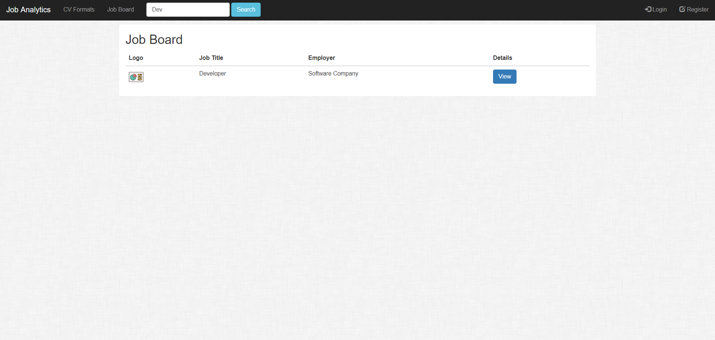

Alternatively, you can just browse the job board by clicking the link labelled “Job Board” in the navigation bar.

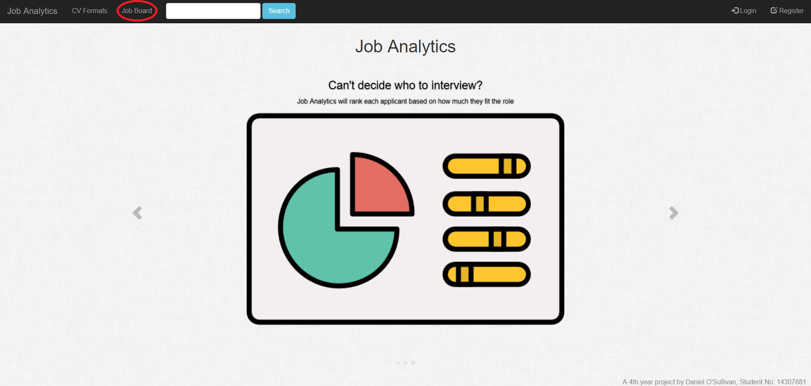

Applying for a job

To apply for a job on the job board, click the blue button labelled “View” under the “Details” heading in the row of the job you want to apply for.

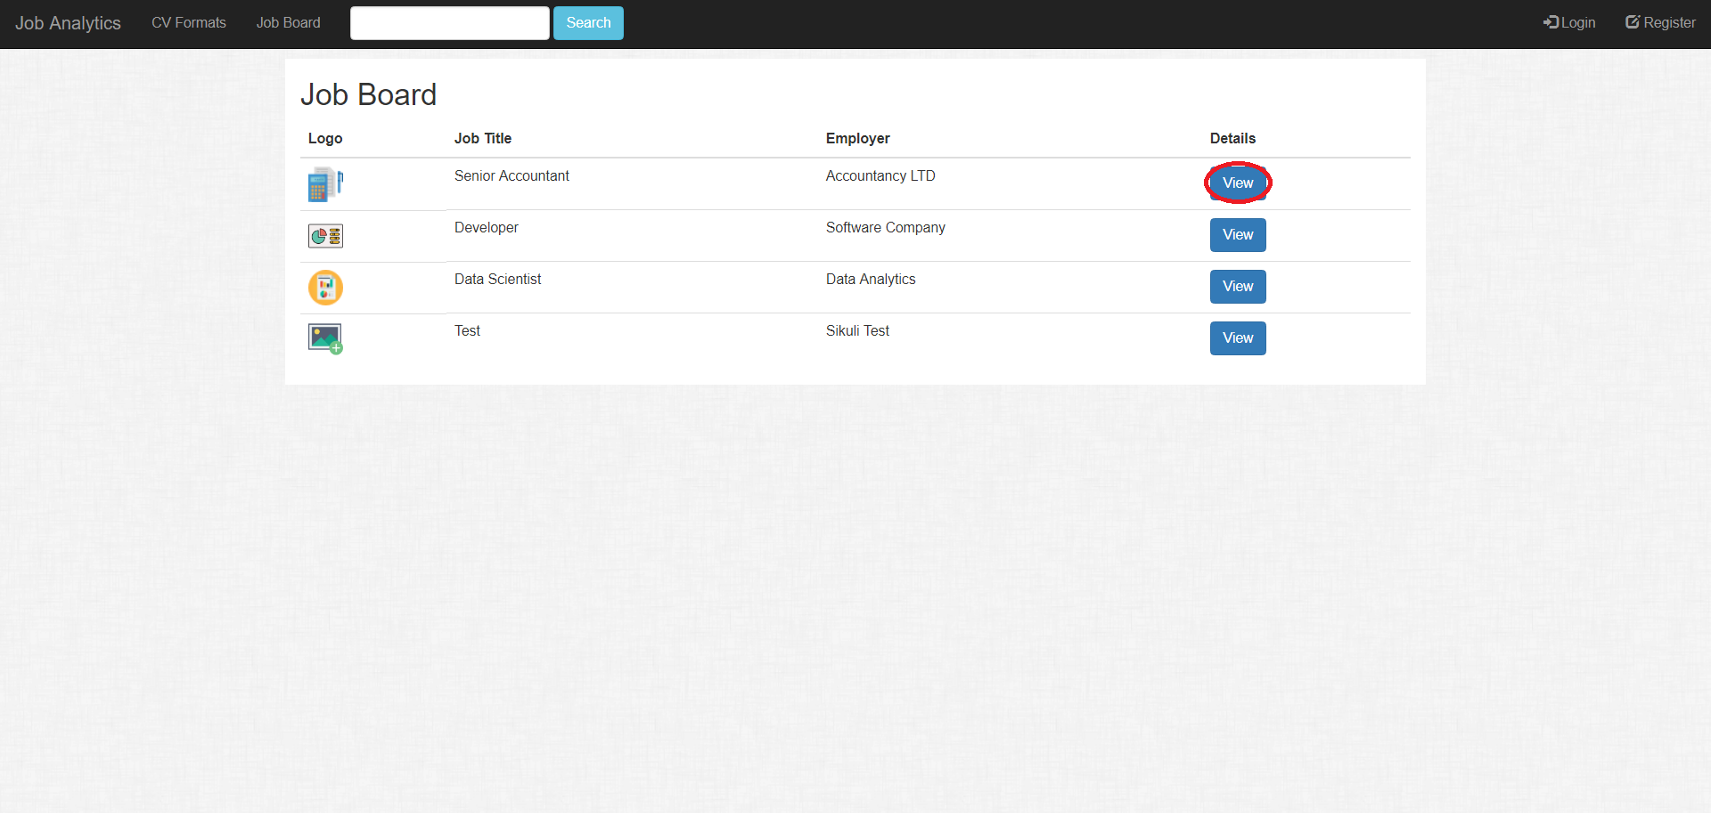

You will be redirected to the information page for that job. Scroll to the bottom and click the green button labelled “Apply”.

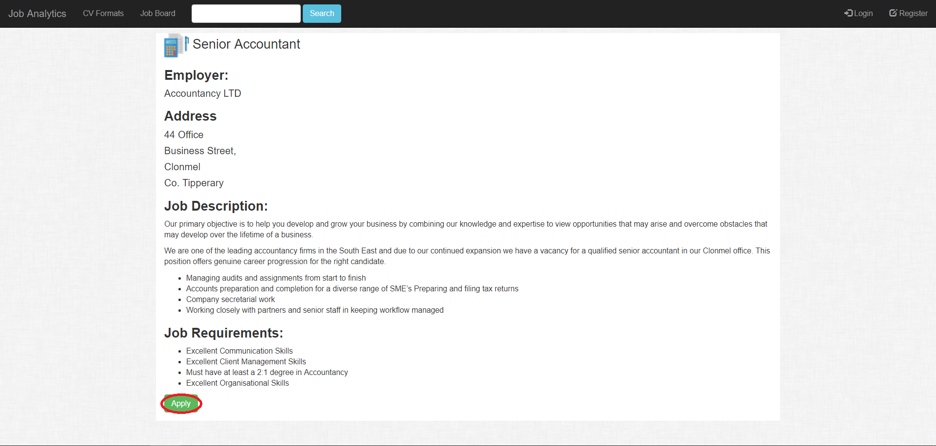

You will then be redirected to step 1 of the application form. There are 3 steps to applying for a job:

1. Upload your curriculum vitae
2. Verify your personal information
3. Answer questions for our prediction algorithm

In step 1, all you need to do is upload your CV. Our CV parser will extract information from your CV for our matching and summarization algorithm. Please make sure your CV structure is in compliance with our one specified in the “CV Format” section. If it is not your CV will be rejected.

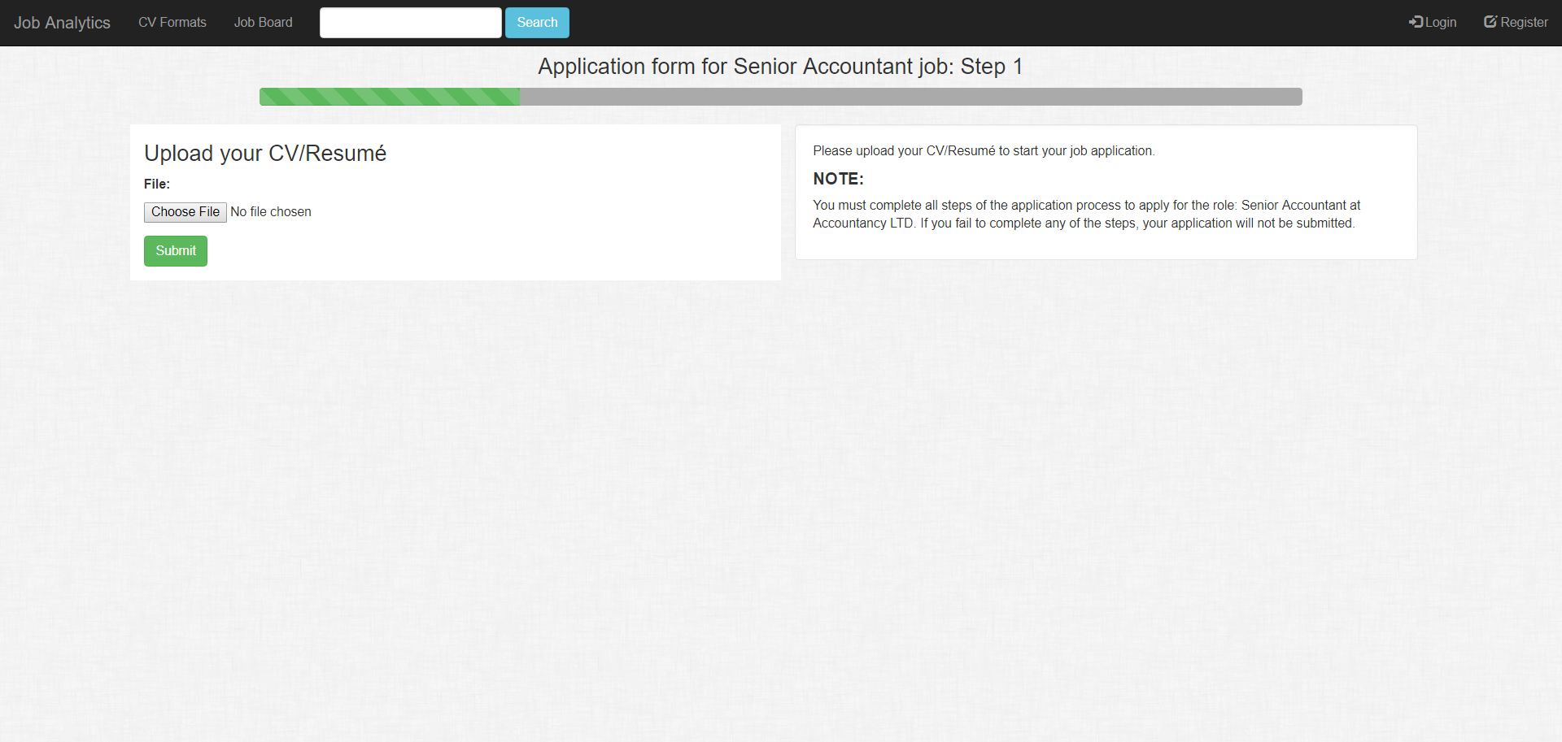

Click the button labelled “Choose File” and upload your CV. Once it is uploaded, click the green button labelled “Submit” to continue to the next step.

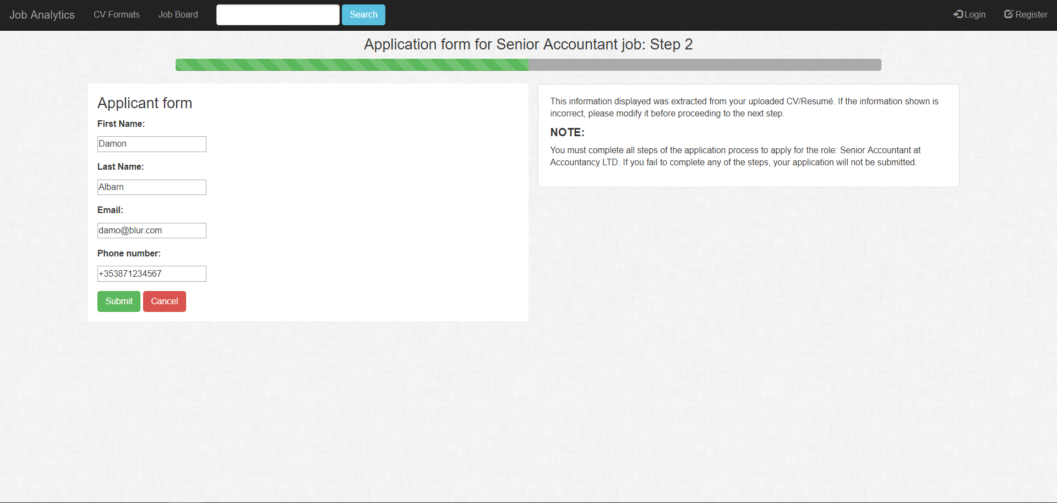

In the next step, some of the form fields will be filled out for you. This is because our CV parser extracted your personal information from your curriculum vitae and uses it in the next step. If the CV parser can’t find one of the fields e.g. it can’t find your phone number, it will leave the corresponding field blank. If the information shown in the fields isn’t correct, you can change it like you can with any other form. Once you verify the information in the fields, click the green button labelled “Submit” to continue on to the next step. Alternatively, if you wish to cancel your application thus far, you can click the red button labelled “Cancel”.

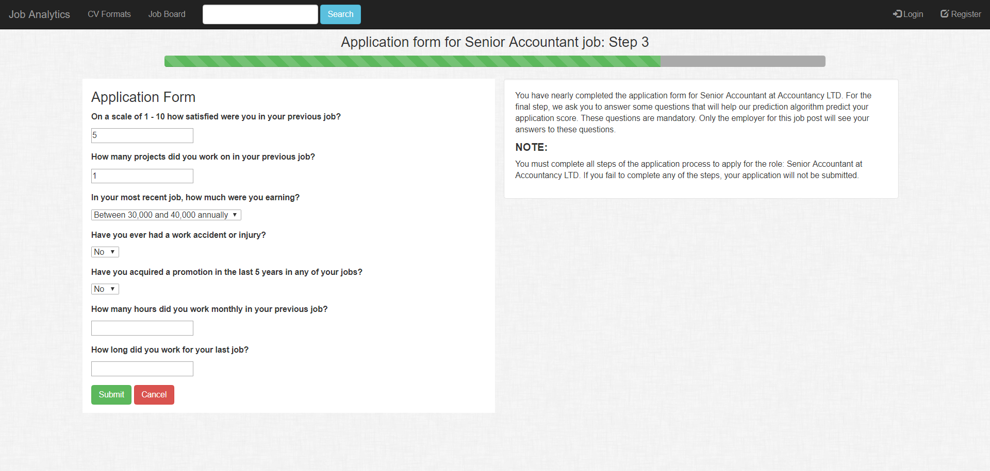

The third step is the final one in the job application process. In this step, we ask the applicant to answer some questions to help our prediction algorithm. These questions include:

* On a scale of 1 - 10 how satisfied were you in your previous job? (with 10 being really happy and 1 being incredibly unhappy)
* How many projects did you work on in your previous job?
* In your most recent job, how much were you earning? 3 choices to choose from:
  + Low (which is earning less than or equal to 30,000 annually)
  + Medium (which is earning between 30,000 and 40,000 annually)
  + High (which is earning more than 40,000 annually)
* Have you ever had a work accident before? (Yes or No)
* Have you acquired a promotion in the last 5 years? (Yes or No)
* How many hours did you work monthly in your previous job?
* How long did you work for your last job?

Please answer these questions as honestly possible in order to get the most accurate prediction. Once you have answered all the questions, click the green button labelled “Submit” to submit your job application. Alternatively, if you wish to cancel your application thus far, you can click the red button labelled “Cancel”. Once you’ve submitted your application, you will be redirected back to the homepage with a green banner stating that you’ve successfully applied for the job.

